MANAGEMENT ACCOUNTING
STUDENT ID:
STUDENT NAME:
ASSIGNMENT CODE:

Table of Contents
Solution 1 3
Solution 2 4
Solution 3 5
A.) History of Naryana Hrudayalaya 5
B) Business/products of the company 6
C) Management/Board of Directors 6
D) Financial Statements 6
E) Director’s report 7
F) Management Discussion and Analysis 7
G) Stock market information 8
H) Peer/Competitors data 8
I) Quarterly results 9
J) Balance sheet and the income statement for the current year 9
Solution 4: Ratio analysis 9
Solution 5: Marginal costing 15
Solution 6: Budgets and Budgetary control 23

Solution 1
A) The ‘What if’ analysis tool is identified as the managerial term that is basically used in the management and cost accounting. Under this analysis, the managers make necessary changes in the amount and the volume to analyze their impact and effect if these are actually changed in future period of time. This specific analysis technique is also referred to as the sensitivity analysis. For example, what if analysis would be applied when the management plans to increase the sales price of products by $3 per unit and can observe what will happen when prices are actually increased.
B) The balance score card is identified as the performance metric that is basically used for attainment of strategic management within the organization through four key perspectives, i.e. customers, financial, learning and growth and internal process.
Financial: The perspective shows that how the shareholders can be managed for gaining long term success (Boscia and McAfee, 2014, January). This perspective helps business to solve their financial problems through a focused approach and thus company can improve long term sustainability. An example could be by enhancing profitability and revenue the business would be able to solve its problems.
Customer: The outlook focuses over how the organization would be perceived by the customers for attainment of objective and vision for gaining necessary trust and confidence of customers. An example could be through effective marketing of high quality products for enhancing customers’ satisfaction.
Internal process: The perspective explains what essential business processes are required for gaining excellence in the organization and how these processes can be effectively implied within the organization. An example could be the constant innovation and quality control would help in attaining trust and relevant publicity within the marketing through the different business processes (Grigoroudis, et. al., 2012).
Learning and growth: The outlook shows how the manager would be able to improve and change its current practices and procedures for gaining necessary sustainability within the organization for future success. The example for this could be taken as through establishment of standardized training procedures and quality building among employees.

Solution 2
The budgeting is identified as the process in which budgets are prepared by the organizations that aims at determination of expected expenses and revenue in respect of different activities and operations of the business for a future period (Bogsnes, 2016). Thus, budgeting process mainly emphasizes over preparation of detailed financial statements and results that helps in the future projection of income and expenses for a specific time period in future. A number of budgets are prepared by organizations like Unilever which are as follows:
Master budget: The Unilever Company prepares this budget which is basically a combination of several individual budgets that helps in providing an overall picture regarding the health and financial activities of business. For example, sales budget, production budget, overhead budget etc.
Cash budget: The Unilever organization by preparing this budget aims at future projection of inflow and outflow of cash within the business in a particular time period (Roncalli, 2013). This helps the organization in proper management of cash for distinct activities.
Operating budget: The Unilever Company, with the help of this budget, is able to effectively forecast and analyze the future expenses and losses over the course of operations for a particular time period (Wildavsky, 2017). Thus, the budgets provide accurate prediction regarding, manufacturing expenses, sales, labor, overhead and material cost along with administrative cost etc.
Static budget: This is the fixed budget prepared by Unilever and does not consider changes that occur in the income as well as the sales volume (Cools, et. al., 2017). The budget is mainly used for proper storage and warehousing of products irrespective of change in inventory level due to entering and leaving of inventory from the godown.
Financial budget: This is the budget that is prepared by the Unilever for effective and proper management of future expenses, cash flow, income and assets of the business (Roncalli, 2013). The budget provides a comprehensive picture regarding financial health and the expenditure with respect to key operations of the business.
Sales budget: This budget helps in proper forecasting of total sales for a specific period and is shown in either through quantity or money terms. The budget is important because all other budgets are prepared on the sales budget.
Production budget: The budget helps in forecasting the output that will be produced during a specific period and is helpful in scheduling the production as per the sales budget.

Solution 3

A.) History of Naryana Hrudayalaya
The healthcare institution is identified as the chain of major multispecialty hospitals in India that is founded by Dr. Devi Prasad Shetty in the year 2000. The hospital is currently having its headquarters located at Bengaluru in India with strong presence in states like Karnataka and other southern states of India (Naryana Hrudayalaya, 2018). The hospital was initially started as a hospital with 225 bed capacity and provided services in heart care and other primary facilities. There is also an international hospital at the in the Cayman Islands.

B) Business/products of the company
The hospital provides advanced healthcare services in more than 30 specialties. The major business products can be identified in the form of services in specialties such as Cancer care, Gastroenterology, Cadiac surgery, Neurology, Cardiology, Neurosurgery, Urology, Orthopedics and Nephrology.

C) Management/Board of Directors
Position | Key person
Chairman and CEO | Dr. Devi Prasad Shetty
Vice Chairman | Dr. Ashutosh Raguvanshi
Executive Director | Viren Shetty
Non-Executive Director | Kiran Mazumdar Shaw
Board of Directors (Independent Director) | Dinesh Krishna Swamy
 | Muthuraman Balasubramanian
 | Arun Seth
 | B N Subramanya
 | Manohar D Chatlani

D) Financial Statements
For the year ending 31 March 2018, the revenue from operations for the organization is Rs. 22,809.07 million while it is Rs 18781.65million in the year 2017. The total income has been Rs 22998.07 million for the year 2018 while it is Rs18956.47in the year 2017 (Naryana Hrudayalaya, 2018). The profit for the year is Rs 514.02million while it is Rs 829.74 million in the year 2017. The income tax expenses have reduced to Rs 289.64million in the current year from 523.66in 2017.

E) Director’s report
The director’s report provides detailed information with respect to the financial and operational performance of the organization. The report enables the shareholders to gain information regarding the related party transactions, non-compliance regarding the capital markets, the whistleblower policy (Naryana Hrudayalaya, 2018). Further, the report also states that the financial statements of the company have materially true and significant and does not hide any material fact that can be misleading. The report also makes sure that the financial statements are prepared in compliance with the relevant accounting standards, laws and regulations.
Performance review of consolidated operations
The directors have commented that in the year under review, the total revenue of the organization has raised to Rs 22998.07mn in the year 2017-18 from Rs 18956.47mn in 2016-17. The earnings before interest, tax, amortization and depreciation and the exceptional items has reduced to Rs 2311.65mn in 2017-18 from Rs 2463.38mn in 2016-17.
Along with the authorized share capital of the company as on 31 March 2018 is Rs 3800mn that is made up of 71000000 preferences shares of Rs 10 each and 309000000 equity shares of Rs 10 each. The directors have also commented that a suitable risk management policy has been formulated with the help of Audi, risk and compliance committee. The directors have also proposed for the insider trading policy.
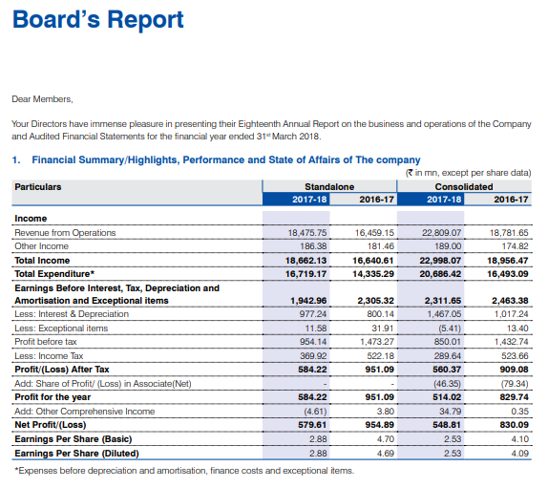

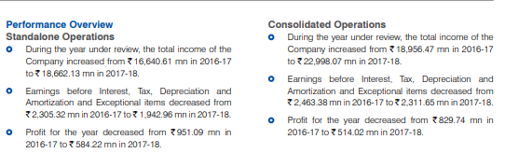

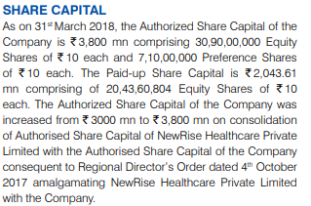

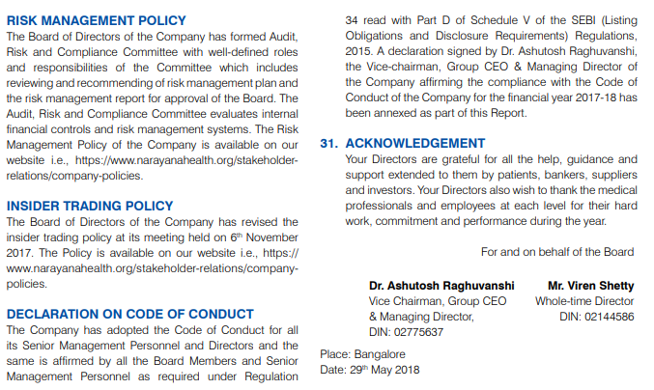

F) Management Discussion and Analysis
The organization aims for maintaining the superior quality standard for clinical excellence, satisfaction and the patient health care. With respect to the governance and accountability, the organization aims for developing an environment that is responsible and transparent so that the highest corporate standards and trust can be achieved with the customers. The organization has also adopted an appropriate Dividend Declaration Policy so that proper dividend can be provided to employees.

G) Stock market information
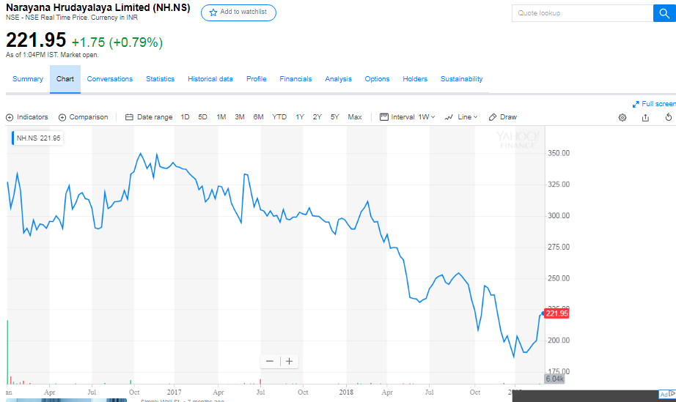
(Source: Yahoo finance, 2018)
The above chart show the five year comparative stock chart of Naryana Hrudayalaya and it can be observed that there is continuously decline over a period of five years in the stock prices of the company. Thus, the organization is required to adopt necessary policies for maintaining its stock prices.

H) Peer/Competitors data
The major competitors of the organization have been identified as Apollo Hospitals, Manipal Hospitals and the Fortis healthcare. The Apollo hospitals are earning revenue of $1.1billion while the Manipal Hospitals are earning revenue of $196million. In case of Fortis, it generates revenue of $628.2million as compared to other major hospital chains of India.

I) Quarterly results
The third quarter results of the company showed the total operating revenue as INR 7321 million while the total expenses were INR 6542 million. The profit after tax for the current quarter was INR 127 million (Naryana Hrudayalaya, 2018). In case of balance sheet, the long term debt showed INR 8174 million in the long term debt for the third quarter while it is INR 51 million for short term debt. The shareholder equity is INR 10568 million in the current quarter.

J) Balance sheet and the income statement for the current year
In the current year, the current assets of the company have increased to Rs 4792 million in 2018 and the non-current assets have increased to 20563.02 million. The total assets have increased to Rs 25355.95 million in the current year. The current liabilities of the company have increased to 5097.66 million in the current period and the noncurrent liabilities have increased to Rs 9897.91million in the present period (Naryana Hrudayalaya, 2018). In case of income statement, the profit before tax has reduced to Rs 803.66 in the current period. This may be due to increase in the expenses which have raised to Rs 22153.47 million in the current year.
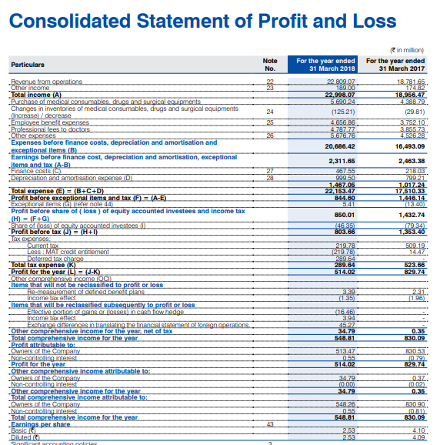

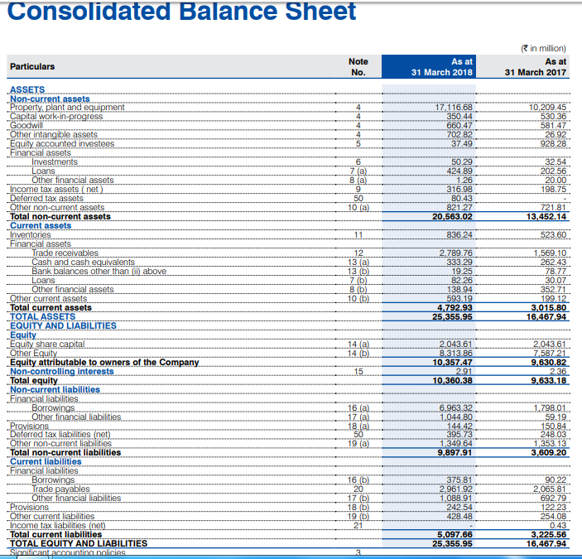
Comment: As per the management views and analysis, the detailed discussion has been made regarding the financial and the operating performance of the organization and the organizations has taken relevant steps for improving the current condition of the company through the distinct function areas. Thus, it is recommended that the new investor can invest in the company for gaining relevant profits and further, in case of the existing investors the organization is making constant improvements in the operations which enhance the long term profitability of the company.

Solution 4: Ratio analysis
Problem 1 | Company A | Company B
Current assets | 500 | 800
Current liabilities | 200 | 300
Current ratio = current assets/Current liabilities | 2.5 | 2.67
profit after tax | 800 | 720
Reserves & Surplus | 2200 | 1900
Equity share capital | 500 | 400
Shareholder's equity | 2700 | 2300
Return on equity= Net income/Shareholder's equity | 0.30 | 0.31
Net Sales | 4500 | 4400
Fixed Assets | 900 | 1000
Turnover to fixed asset= Net sales /fixed asset | 5 | 4.4
Current liabilities | 200 | 300
Non current liabilities (Term loan) | 200 | 500
Shareholders' fund | 2700 | 2300
Debt equity ratio= Total debt/Shareholders' equity | 0.07 | 0.22
Profit after tax | 800 | 720
No. of Equity shares | 500 | 400
EPS= Profit after tax/Total number of equity shares | 1.6 | 1.8
Dividend per share | 1 | 1.1
Earnings per share | 1.6 | 1.8
Dividend payout ratio= DPS/EPS *100 | 62.5 | 61.1
Equity | 500 | 400
Reserves and surplus | 2200 | 1900
Profit after tax | 800 | 720
Book value per share | 3.8 | 3.95
Market price share | 15 | 16.5
price to book value | 3.95 | 4.18
Market price per share | 15 | 16.5
Earnings per share | 1.6 | 1.8
Price to earnings ratio= MPS/EPS | 9.38 | 9.17

Problem 2
Current assets | 30
Current liabilities | 10
Current ratio | 3
Total debts | 50
Shareholder's equity | 170
Debt equity ratio | 0.29
Net Sales | 630
Fixed Assets | 90
Turnover to fixed assets | 7
Profit after tax | 60
Shareholders' equity | 170
Return on equity | 35%
Total assets | 220
Current liabilities | 10
Capital employed | 210
profit before tax | 90
Return on capital employed= Profit before tax/capital employed | 43%
Profit after tax | 60
Number of equity shares | 10
EPS | 6
Operating profit | 60
Net Sales | 630
Operating profit ratio | 10%
MPS | 7.2
EPS | 6
price to earnings ratio | 1.2

Problem 3
Net Sales | 3600000
Total assets | 1200000
Fixed assets | 720000
Current assets | 480000
Inventory | 180000
Debtors | 240000
Current liabilities | 240000
Net Worth | 480000
Long term debt (loans) | 480000
Cash | 60000

Balance sheet
Liabilities | Amount | Assets | Amount
Net Worth | 480000 | Fixed assets | 720000
Long term loans | 480000 | Stock | 180000
Current liabilities | 240000 | Debtors | 240000
 |  | Cash | 60000
Total | 1200000 | Total | 1200000

Problem 4
Profit and loss account
For the year ended 2016-17
Particulars | Amount | Particulars | Amount
Cost of Sales | 37057 | Net revenue | 59289
Gross profit c/d | 22232
Selling and marketing expenses | 2728 | By Gross profit b/d | 22232
General and Adm. exp. | 3628
Total operating expenses | 6356
Operating profit | 15876
 |  | By Operating profit | 15876
 |  | Other income | 3062
Net profit before tax | 18938 | By Net profit before tax | 18938
Tax expenses | 5120
Net profit after tax | 13818

Question 6:
Operational performance ratio
Operating performance ratio: Net sales / net property plants and the equipment
Operating performance ratio:
 | 17-18 | 16-17
net sales | 2019.75 | 1649.05
Net property plants and the equipment | 1360.08 | 1399.37
Operating performance ratio | 1.49 | 1.18
performance ratio of the company is improving as compared to that of the last year.

Liquidity and the profitability ratio:
Current ratio: Current assets / Current liablities
 | 2018 | 2017
Current assets | 596.27 | 508.63
Current liablities | 2757.12 | 2271.42
current ratio- | 0.22 | 0.22

Quick ratio: Liquid assets/ Current liabilities
 | 2018 | 2017
Current assets | 596.27 | 508.63
Inventories | 299.91 | 296.62
Liquid assets | 296.36 | 212.01
Current liabilities | 2757.12 | 2271.42
Quick ratio | 0.11 | 0.09
Liquidity position of the company is same as compared to that of the last year, but company need to make the improvement in the generating the liquid assets in the company.

Profitability ratios:
Gross margin ratio: gross profits/ net sales*100
 | 2018 | 2017
Gross profit | 719.71 | 564.56
net sales | 2019.75 | 1649.05
gross profit ratio | 35.63 | 34.24
Operating margin ratio: operating profit / net sales*100
 | 2018 | 2017
operating profits | 214.4 | -145.24
net sales | 2019.75 | 1649.05
operating profit ratio | 0.11 | -0.09

Performance of the company is improving as compared to that of the last year.

Captital structure ratio:
Debt to equity ratio: Debt / Equity
 | 2018 | 2017
Debt | 412.53 | 990.43
Equity | 1800.56 | 1615.43
debt equity ratio | 0.23 | 0.61
Asset coverage ratio: (Total asset - Intangible assets) - (Current liablities - short term debts)/Total debts
 | 2018 | 2017
Total assets | 4970.21 | 4877.28
Intangible asset | 0 | 0
Net assets | 4970.21 | 4877.28
Current liablities | 2757.12 | 2271.42
Short term debts | 1682.75 | 1437.41
Current liablities - Short term debts | 1074.37 | 834.01
Total debts | 3169.65 | 3261.85
Asset coverage ratio | 1.23 | 1.24

Performance of the company is improving in terms of the capital structure, the company is operating on the own funds but is generating the less revenue from the assets employed in the company as compared to that of the last year.

Solution 5: Marginal costing
Problem 1
Fixed Cost | 250000
Variable cost | 750000
sales | 1125000
Output (units) | 75000
Contribution | 375000
Profit earned during the year | 125000

Problem 2
Sales | 100000
Variable cost | 70000
Contribution | 30000
P/V ratio | 30%
Profit | 10000
Fixed cost | 20000
Sales Volume to earn a profit of 40000 | 2

Problem 3
Direct material | 5
Direct labor | 2
Direct overhead | 2
Variable cost per unit | 9
Fixed cost | 90000
Selling price per unit | 12
Contribution per unit | 3
P/V ratio | 25%
Break Even Sales (in units) | 30000
Break Even Sales (in RO) | 360000
Sales for earning a profit of 450000 | 2160000

Problem 4
Change in Profits | 200000
Change in Sales | 1000000
P/V ratio | 20%
Fixed Cost for the period 1 | 200000
Sales required to earn profit of 500000 | 3500000
Profit when sales are 1000000 | 500000

Problem 5
Change in profits | 8000
Change in sales | 20000
P/V ratio | 40%
Fixed cost for the period 1 | 25000
BEP | 62500
Profit for estimated sales of 125000 | 25000
Sales for earning a profit of20000 | 112500

Problem 6:
Sales | 2000000
Variable cost | 1200000
Contribution | 800000
Contribution per unit | 8
fixed cost | 400000
BEP in units | 50000

Problem 7
Change in profits | 4000
Change in sales | 20000
a.) PV ratio | 20%
sales in 2015 | 220000
Fixed cost | 30000
b.) Break even point | 150000
desired Profit | 18000
Fixed cost | 30000
contribution | 48000
PV ratio | 20%
c.) sales in RO | 168000

Problem 8:
Particulars |  | current capacity 70% |  | offer units
Total capacity |  | 19000 |  | 5000
Utilization capacity |  | 13300
Ideal capacity |  | 5700
Sales price per unit | 21 | 21 |  | 15
Sales in value |  | 279300 |  | 75000
Less variable cost | 11.8 | 156940 |  | 59000
contribution | 9.2 | 122360 |  | 16000
less: Fixed cost |  | 79800 |  | 0
Profits |  | 42560 |  | 16000
a) Offer of 1000 units should be accepted instead of 5000 units
b) For making the production of the 10000 units company have to make the sacrifice of the 4300 units from the current production units and have to sacrifice the contribution of RO 9.2 per unit for earning the contribution of RO 3.2 per unit. And the company will also incurred the additional fixed cost for making the production of the 10000 units as this production of 10000 units exceeds the idle production capacity of the company which is 5700 units @ 6=25800
c) Company should accept the proposal to buy the 5000 units @15 from the local buyer because in this case also the company will not be incurring any of the additional fixed cost and the contribution earned by the company is the profit earned by the company.
d)If the buyer of the products of the company is government then the minimum cost that can be quoted to the government will be equal to that of the variable cost of production of the company.

Problem 9:
Alternative a:
Particulars | a | B
units | 500 | 500
Selling price | 50 | 40
Sales price | 25000 | 20000
less: Direct material | 8000 | 6000
less direct wages | 6000 | 4000
variable overhead | 9000 | 6000
Total variable overhead cost | 23000 | 16000
contribution | 2000 | 4000
Fixed cost | 1500 | 1500
Profits | 500 | 2500
Total profits | 3000

Alternative B:
Particulars | B
Units | 800
Sales price | 40
Sales value | 32000
less: Direct material | 9600
Less: direct wages | 6400
less: Variable overhead | 9600
total variable cost | 25600
Contribution | 6400
fixed cost | 1500
profits | 4900

Alternative c:
Particulars | A | B
Units | 800 | 200
Selling price | 50 | 40
Sales value | 40000 | 8000
Direct cost | 12800 | 2400
Direct wages | 9600 | 1600
Variable overhead | 14400 | 2400
Total variable cost | 36800 | 6400
Contribution | 3200 | 1600
Fixed overhead | 1500 | 1500
Profits | 1700 | 100
Total profits | 1800

Alternative D
Particulars | A | B
Units | 300 | 700
selling price | 50 | 40
Sales value | 15000 | 28000
Direct cost | 4800 | 8400
Direct wages | 3600 | 5600
Variable overhead | 5400 | 8400
total variable cost | 13800 | 22400
Contribution | 1200 | 5600
Fixed overhead | 1500 | 1500
Profits | -300 | 4100
Total profit | 3800
Decision | Alternative B should be selected

Problem 10:
 | Present performance | Selling price redued by 10% | Selling price to be reduced by 20%
Unit | 100000 | 111111
selling price | 200 | 180 | 160
sales value | 20000000 | 20000000
cost:
Material | 60 | 60 | 60
wages | 20 | 20 | 20
variable overhead | 20 | 20 | 20
total cost | 100 | 100 | 100
contribution | 100 | 80 | 60
Fixed cost | 50
Profits | 50
 | If the selling price is to be reduced by 10% | If selling price to be reduced by 20%
sales in value
Fixed cost | 5000000 | 5000000
Desired profit | 5000000 | 5000000
Existing sales price | 200 | 200
Contribution per unit:
selling price | 180 | 160
less: total variable cost | 100 | 100
Contribution per unit | 80 | 60
Sales in units | 125000 | 166666.67

Problem 11:
Part A.
Calculation of the break even point in units and the value
Total fixed cost | 36000
selling price | 3
total vatiable cost | 2.1
Contribution per unit | 0.9
Break even point in units | fixed cost / contribution per unit
BEP (Units) | 40000
PV Ratio | 0.3
BEP In value | 120000
Units sold | 35000
Selling price | 3
sales value | 105000
Less: Variable cost | 73500
Contribution | 31500
Less: Fixed cost | 36000
Loss | -4500
Part b:
selling price | 3
variable cost | 1.95
Contribution per unit | 1.05
Fixed cost | 27000
Break even points in unit | 25714

Problem 12
particulars | present performance | proposal 10000 units
present operating capacity | 50%
idle capacity | 50%
sales | 40000 | 10000
sales in value | 560000 | 130000
selling price per unit | 14 | 13
less; Direct material | 160000 | 40000
Direct labor | 80000 | 20000
Variable overhead | 240000 | 60000
total variable cost | 480000 | 120000
Contribution | 80000 | 10000
less fixed cost | 160000 | 0
Loss | -80000 | 10000

Decision: Company should accept the offer because if the company accepts the offer then the total loss of the company will get reduced by the profit of RO 10000 incurred on acceptance of offer.

Solution 6: Budgets and Budgetary control
Problem 1:
Particular | August | September | October | November | December
Sales | 50000 | 52000 | 66000 | 60000 | 70000
Material | 32400 | 30000 | 36000 | 30000 | 38000
wages | 7600 | 7600 | 8000 | 8400 | 9000
Overheads | 3800 | 4200 | 4600 | 4800 | 5000
Cash Budget
Particular | August | September | October | November | December
Opening balance |  |  | 8000 | 16800 | 34200
collection from the debtor |  | 50000 | 52000 | 66000 | 60000
total receivable |  |  | 60000 | 82800 | 94200
payment:
Advance tax |  | 5000 |  |  | 5000
Payment to creditor 10% | 3240 | 3000 | 3600 | 3000 | 3800
Payment to creditor 90% |  | 29160 | 27000 | 32400 | 27000
wages | 7600 | 7600 | 8000 | 8400 | 9000
overheads | 3800 | 4200 | 4600 | 4800 | 5000
Total payment |  |  | 43200 | 48600 | 44800
Closing balance |  |  | 16800 | 34200 | 49400

Problem 2:
Particular | August | September | October | November | December
Sales | 140000 | 172000 | 176000 | 150000 | 160000
Material | 120000 | 120000 | 119600 | 120000 | 121000
wages | 17600 | 17600 | 18000 | 18400 | 19000
Overheads | 13800 | 14200 | 14600 | 14800 | 15000
Cash Budget
Particular | August | September | October | November | December
Opening balance |  | 58000 | 12000 | 34240 | 20000
Collection fron debtor 50% | 70000 | 86000 | 88000 | 75000 | 80000
Collection fron debtor 50% |  | 70000 | 86000 | 88000 | 75000
Total receipt | 70000 | 214000 | 186000 | 197240 | 175000
payments:
Advance tax |  | 15000 |  |  | 15000
Payment to creditors 10% | 12000 | 12000 | 11960 | 12000 | 12100
Payment to creditor 90% |  | 108000 | 108000 | 107640 | 108000
wages |  | 17600 | 17600 | 18000 | 18400
Overheads |  | 13800 | 14200 | 14600 | 14800
Purchase of the machinery |  |  |  | 25000 | 25000
Total payment | 12000 | 166400 | 151760 | 177240 | 193300
Closing balance | 58000 | 47600 | 34240 | 20000 | -18300

Problem 3:
particulars | June | july | august | september
cash sales | 120000 | 140000 | 152000 | 121000
Credit sales | 100000 | 80000 | 140000 | 120000
Purchase | 160000 | 170000 | 240000 | 180000
Other expenses | 18000 | 20000 | 22000 | 21000
Wages | 21000 | 22000 | 23000 | 24000
Cash budget
Particulars | June | July | August | September
opening cah balance |  | 22000 | 37000 | 53500
receipts:
Cash sales | 120000 | 140000 | 152000 | 121000
50% of the credit sales | 45000 | 36000 | 63000 | 54000
50% of the credit sales |  | 47500 | 38000 | 66500
Total receipt | 165000 | 245500 | 290000 | 295000
Payments:
Purchase 25% | 40000 | 42500 | 60000 | 45000
purchase 75% |  | 120000 | 127500 | 180000
Wages |  | 21000 | 22000 | 23000
Other expenses | 18000 | 20000 | 22000 | 21000
Interest payable | 5000 | 5000 | 5000 | 5000
Total payment | 63000 | 208500 | 236500 | 274000
Closing balance | 102000 | 37000 | 53500 | 21000

Problem 4:
Particulars | February | March | April | May | June
sales | 60000 | 62000 | 64000 | 58000 | 56000
Material | 36000 | 38000 | 33000 | 35000 | 39000
Wages | 9000 | 8000 | 10000 | 8500 | 9500
Overheads | 4000 | 4200 | 4600 | 4800 | 4000
Cash Budgets
Particulars | February | March | April | May | June
Opening balance |  |  | 5000 | 20500 | 39150
Receipt:
cash sales | 6000 | 6200 | 6400 | 5800 | 5600
50% of the credit sales | 27000 | 27900 | 28800 | 26100 | 25200
50% of the credit sales |  | 27000 | 27900 | 28800 | 26100
Total receipts | 33000 | 61100 | 68100 | 81200 | 96050
Payments:
Payment to creditor |  | 36000 | 38000 | 33000 | 35000
Advance tax |  |  |  |  | 8000
Overheads | 4000 | 4200 | 4600 | 4800 | 4000
Wages | 4500 | 4000 | 5000 | 4250 | 4750
Total payment | 8500 |  | 47600 | 42050 | 51750
Closing balance |  |  | 20500 | 39150 | 44300

References
Bogsnes, B., 2016. Implementing beyond budgeting: Unlocking the performance potential. John Wiley & Sons.
Boscia, M.W. and McAfee, R.B., 2014, January. Using the balance scorecard approach: A group exercise. In Developments in Business Simulation and Experiential Learning: Proceedings of the Annual ABSEL conference (Vol. 35).
Cools, M., Stouthuysen, K. and Van den Abbeele, A., 2017. Management control for stimulating different types of creativity: The role of budgets. Journal of Management Accounting Research, 29(3), pp.1-21.
Grigoroudis, E., Orfanoudaki, E. and Zopounidis, C., 2012. Strategic performance measurement in a healthcare organisation: A multiple criteria approach based on balanced scorecard. Omega, 40(1), pp.104-119.
Naryana Hrudayalaya, 2018.Annual report. [Online] https://www.narayanahealth.org/sites/default/files/download/annual-reports/NHL_Annual_Report_2017-18.pdf [Accessed 5 March 2019].
Roncalli, T., 2013. Introduction to risk parity and budgeting. CRC Press.
Wildavsky, A., 2017. Budgeting and governing. Routledge.
Winston, W., 2016. Microsoft Excel data analysis and business modeling. Microsoft press.
Yahoo Finance, 2018. Stock Chart. [Online] [Accessed 5 March 2019].

