Marketing Plan Report

Student Name:

University:

Deadline: 11 March 2019

Executive Summary
New Zealand is known for its differently rich culture and has been known as a paradise for adventurers around the globe. It has in fact served the notoriety for all the adventuring, climbing and touring and adrenaline-rushing activities. With the country's natural beauty is like highlighting a great scenery, the new challenge talks about New Zealand's warm and inviting society, welcoming adventurers and tourists in to share this unprecedented piece of the world. New strategies and research methods are the key focuses to actualize in the area of promoting adventurers to make New Zealand as a country of beautiful landscapes and an adventurous nation of the entire world. The travel industry of the country has built up a procedure to focus on the superior adventuring travel division. New Zealand can accommodate this specialty part and the travel industry will concentrate on focusing on undiscovered interest past the compass of premium organizations in the country.
Associations and all the more extensively, a collective methodology will be vital to the conveyance and accomplishment of the travel industry's product's procedure. This incorporates working side by side the Tourism Industry Association as it drives the industry in the improvement of an adventure travelling industry plan. Our focus product to promote New Zealand's tourism is the adventure sport activities. A whole lot of young people as well as different age group people travel to New Zealand to experience the adventure activities that the country has to offer.
A well planned marketing strategy to promote the adventure activities under New Zealand's tourism is going to benefit the country's economy at a great level. The country has planned a target for 2025, according to which, the adventure activities promoted under Tourism industry is going to boost the economics of the country.

Contents
Introduction 5
Statement of Purpose 5
Situational Analysis 5
1. Economics Benefits Analysis 5
2. Market Feasibility Analyses 5
3. Market Structure Analysis and Trends 6
4. PESTEL Analysis 8
i. GDP Contribution 8
ii. Employment Contribution 8
iii. Visitor exports 9
iv. Investment 9
Consumer Behaviour and Trends 10
Marketing Mix plan for New Zealand's Adventure tourism 11
7P's of Promotional Mix 12
Distribution Channels 15
1. Traditional / offline media: 16
2. Word-of-mouth: 16
3. Destination websites: 17
4. Travel agencies: 17
5. Guide books: 17
6. Social media: 17
7. Airline & hotel websites: 17
Why is there a need for promotional tools? 17
Integrated Marketing Communication (IMC) Planning 18
1. Doing a Situational Analysis 19
2. Choosing the target Markets 19
3. Choosing the correspondence Objectives 19
Create brand mindfulness by promoting: 19
Change client convictions by improving brand picture: 20
Increment deals: 20
Determining leaflet/site/destinations: 20
Timing: 20
4. Financial plan 20
Cooperating and bundling products: 21
Pick products that supplement one another: 22
Build up a deals and advertising procedure: 22
Dole out one gathering to deal with appointments and organization: 22
Working with Inbound Operators: 22
Building International Relationships: 22
5. Marketing Mix Strategy 23
6. Assessing the Program 24
Conclusion 25
References 26

Introduction
For many businesses, growth is only achievable by taking risks. Whether this means entering new markets, creating new products and services, increasing tourism attractions, or investing in infrastructure, all options present some degree of uncertainty. The aim of this project is to develop a strategic marketing plan for New Zealand as a tourism destination. Fully understanding the tourism product offerings by New Zealand is crucial in order to market it successfully. Understanding the dynamics of the target market and its key trends is also important to reduce risk and maximize revenue and market share.

Statement of Purpose
The adventure travel industry is quickly developing and the latest years have indicated a greater amount of its beneficial outcomes on the travel industry. The travel industry is one of the quickest developing enterprises on the planet. The interest of voyaging is developing each year and new innovative products to supply in this segment are expanding. It has included into new bearings inside the visitor market. The primary point is to build up a good marketing plan for adventure activities industry for the advancement of New Zealand Tourism industry in Nepal. The key component of the promoting focused to the seven P's of marketing blend, best advertising channels; focus on visitors who were focused by age and the particular adventure activities taken up by the visitors. The exploration would like to discover the correct advertising devices to use for advancement for New Zealand Tourism.

Situational Analysis

1. Economics Benefits Analysis
Travel and transport, settlement and providing food, relaxation, diversion and stimulation, advancing and creating make the most of the job openings in the travel industry. The demand as well as the supply side of the goal in the travel industry is pretty obvious. The demand side depicts the targets: as the people travel, they pick the settlement where they need to remain. The supply side portrays the targets: as the visitors know the topographical regions that they are travelling to, they endorse for the travel industry advertising and arranging. The travel industry products, area and the arrangement of products dependably rely on the travel industry which impacts its administration.

2. Market Feasibility Analyses
As indicated by the Nepal Department of Immigration, a sum of 288,918 global sightseers visited Nepal in the initial three months (January, February and March) of 2018, with a solid addition of 14.20%. The landings from India, Bangladesh, Sri Lanka and Pakistan recorded positive developments of 15.2 %, 35.3%, 3.6% and 20.5 % individually in January 2018 in contrast with the figure of same month in 2017. Essentially, the general landings from the SAARC nations enrolled a positive development of 18.1% as looked at a year ago (Steinmetz, 2018). Albeit Indian and Sri Lankan landings diminished by 32.4% and 17.4%, with a general lessening of 17.9% in February 2018, the district saw a positive development of 7.8 % in March 2018. The expansion was because of the strong development of 39.1% in the Indian guests to Nepal.
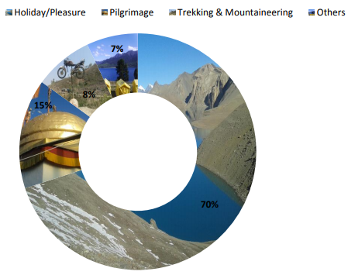
Source: Nepal Tourism Board 2018

3. Market Structure Analysis and Trends
The adventurous explorers went long distances on the planet and required convenience, nourishment, transport and guide in the history. Nepal is taken as the hotspot goal for mountain climbers, white water surfers, shake climbers and individuals looking for undertakings. The Hindu and Buddhist legacy of Nepal and its climate are likewise solid fascination and group pullers (NTB, 2017). Nepal as wellsprings of such huge numbers of common marvels which have been found from Far-East Mechi to Far-West Mahakali zone, from south Terai to the snow-topped Himalayas in the north. Various vacation spot are accessible wherever in Nepal including the most elevated pinnacle of the world-Mount Everest, the origin of Gautam Buddha-Liunbini, rich with biodiversity and incredible land varieties. World well known news channel-CNN has enrolled Everest Region of Nepal as one number goal of the world. Nepal is bit by bit increasing unmistakable significance for its temperament excellence, intriguing spots, extreme adventure, hospitality and pleasure travelling.
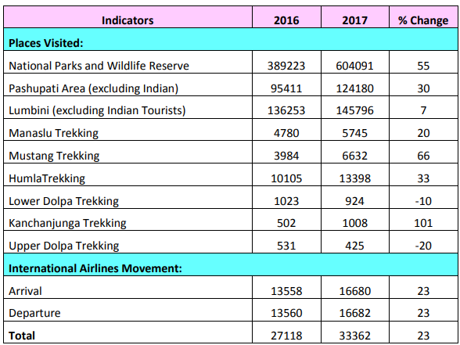
Source: Nepal Tourism Stats, 2017
Nepal earned Rs 67.09 billion from its travel industry in FY 2017-18. Nepal encounters Autumn in the period between September-November, which is considered the 'best time' to visit the Himalayan Nation. As indicated by Nepal Tourism Board (NTB), 91, 820 outsiders visited Nepal in September 2018 alone.
Right now, the Nepal the travel industry is doing great passing by the quantity of voyagers who have visited the nation since January 2018. NTB has recorded a sum of 772, 798 outsiders, which has expanded by 20 percent contrasted with a similar period in 2017.
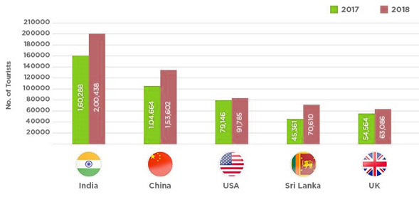
Source: Nepal tourism Board, 2018

4. PESTEL Analysis
According to the report presented by WTTC, the key economic factors of Nepal Tourism for the year 2017 are discussed (TRAVEL & TOURISM ECONOMIC IMPACT 2017 NEPAL, 2017):

i. GDP Contribution
Income from the travel industry area is seen from remote cash trade made by visitors and the travel industry businesses as intermediary of salary. All residential commitment isn't caught. Nepal Rastra Bank report demonstrates absolute outside money trade (less return) for 2016/017 remained at Nrs. 58,526,918 thousand, (Around 551,000 thousand US$). This is practically 40% higher than earlier year 2015/016. This expansion in cash salary because of increment in vacationer entry brings per traveler every day use at 54 USD.
The report said that the immediate commitment of movement and the travel industry to the GDP in 2016 was Rs85.2 billion, or 3.6 percent. This is gauge to ascend by 6.8 percent to Rs91 billion out of 2017. Nepal is positioned 37th as far as movement and the travel industry direct commitment to GDP among 185 nations overviewed.
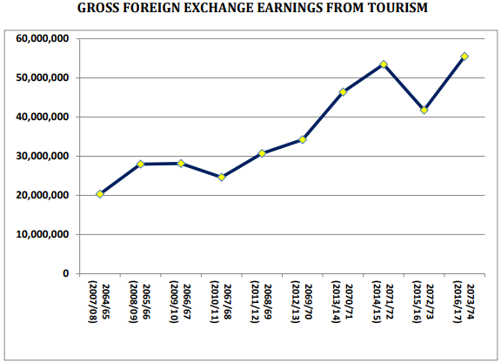
Source: Nepal Tourism Stats, 2017

ii. Employment Contribution
Nepal's tour and the travel industry division siphoned Rs177 billion into the economy and bolstered in excess of 427,000 employments a year ago, the World Travel and Tourism Council (WTTC) said. As indicated by its yearly Economic Impact Research report for 2017, the travel industry represents 7.5 percent of Nepal's GDP and is conjecture to rise 4.3 percent every year to Rs287.6 billion, or 8.3 percent of the GDP in 2027. The GDP created straightforwardly by the movement and the travel industry segment incorporates its roundabout and instigated impacts (Prasain, 2017).
New jobs created by the tourism industry in 2017 is 6.6 percent of the total jobs created in 2017. In the year 2016, new investments had created 945,000 jobs, including 427,000 people in the tourism sector.
The total contribution of the travel industry to work, including more extensive impacts from venture, the production network and prompted salary impacts, was 945,000 employments in 2016. This is gauge to increment by 5.4 percent in 2017 to 996,000 employments. The report has estimate that by 2027, the industry is relied upon to help 1,325,000 occupations.

iii. Visitor exports
Foreign vacationer landings to Nepal bounced 39.71 percent to 753,002 of every 2016. Guest trades produced Rs48.6 billion, or 17.7 percent of all out fares in 2016. In 2017, this is relied upon to develop by 9 percent, and the nation is required to draw in 801,000 universal traveler entries.

iv. Investment
The report published by World Travel and Tourism Council (WTTC) 2018 shows total investments in tourism sector reached Rs 17.3 billion in 2017 compared to Rs 16.5 billion in 2016. Total investment in tourism sector in 2017 was 2.3 percent of the total investments in the country. The council estimates investments in Nepal's tourism sector to increase by 7.6 percent in 2018 and by 4.7 percent annually over the next decade to reach Rs 29.4 billion in 2028.Travel and tourism investment includes investment activities like buying aircraft, constructing hotels and investment in other tourism activities.
The travel industry segment of Nepal is dealt with association of Government, private segment, family units, experts and NGOs. The travel industry ventures assume significant jobs in visitor administration, administration the board, expanding income. All complete 1101 (star and visitor standard lodgings) are worked in 2017, with bed limit 39833 every day. Travel organization, visit control, visit administrators, boating offices, trekking offices and aides all are in expanding number of pattern. In 2017 the quantity of enlisted Travel offices came to up to 3824 and Trekking organizations are 2637.
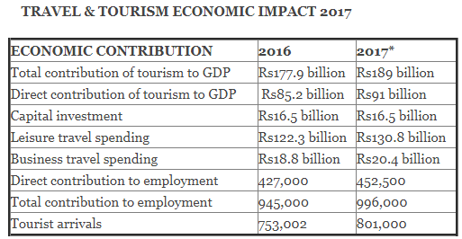
Source: WTTC, 2017

Consumer Behaviour and Trends
Nepal is prestigious for experience the travel industry because of its conspicuous pinnacles. The quantity of undertaking allowed groups has come to 291 while 2277 in people. Out of them 1225 succeeded summit to different pinnacles made by 692 outside and 533 Nepalese. The most noteworthy number of climbers originates from USA, Germany and United Kingdom separately.
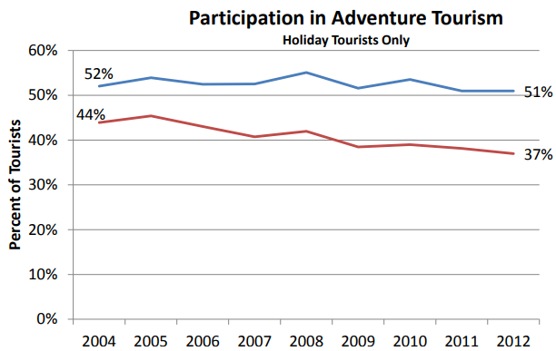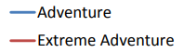
Source: IVS 2016
Jet boating, glacier walks and the luge are the mainstream adventure tourism activities embraced by universal adventurers. In 2012 more than 500,000 worldwide occasion travelers took part in different types of adventure tourism amid their stay in Nepal. This amounts to 51 percent of Nepal's tourism market. 367,000 worldwide holiday sightseers took an interest in outrageous adventure tourism amid their stay in Nepal. This is equal to 37 percent of the tourists on holidays.
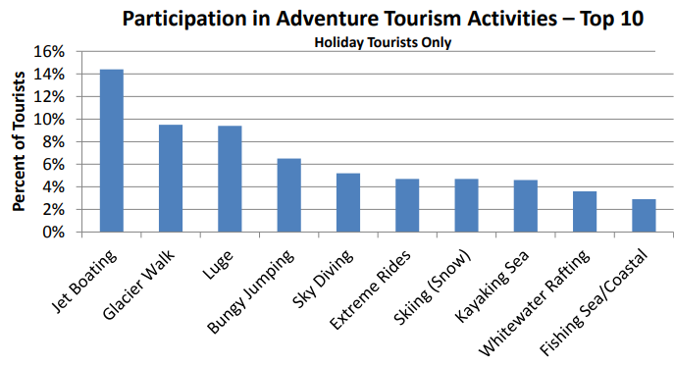Source: IVS 2016
Obviously youth are bound to take part in adventure activities. The most common age group to go for adventure activities during their stay in Nepal is 20 to 45 year old.
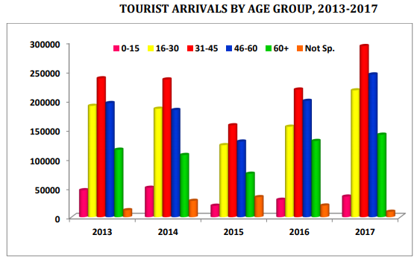
Source: Nepal Tourism Board, 2017
Moderately aged and more established travelers still take an interest in adventure tourism, although they are somewhat more averse to do adventure tourism activities amid their stay in Nepal. The older people are more uncertain to be keen on taking an interest in adventure tourism.

Marketing Mix plan for New Zealand's Adventure tourism
Marketing is the most widely recognized event utilized by businesses and ventures to build up, course the way and investigate their market. The American Marketing Association's (AMA) characterizes it as "the arrangement of the set of foundations and events for ingenious communication and trade contributions that carries the incentive for clients, customers, accomplices and society at large is called marketing." In the travel industry, promoting is incredible for traveler goal and for the entire travel industry. "Advertising is the way toward accomplishing intentional trades between two groups" (Middleton, 2009)
It is difficult to sell your tourism product except if the organization does not have enough advertising procedure. High-volume, low-aptitude, low-value, brief span products on offer at exceedingly open mass-market adventure tourism industry destinations depend heavily on advertisement.

7P's of Promotional Mix
Varieties in marketing blends don't happen by possibility. Advertising supervisors devise marketing methodologies to pick up points of interest over culminations and best serve the requirements and needs of a specific target market fragment. By controlling components of the promoting blend, advertising administrators can adjust the client offering and can make focused progress. As regular the advertising blend contains of the whole fixation that the organization can do to benefit and control to indicate result for its product. The numerous potential outcomes are gathered into 7 group of factors called as "7Ps".
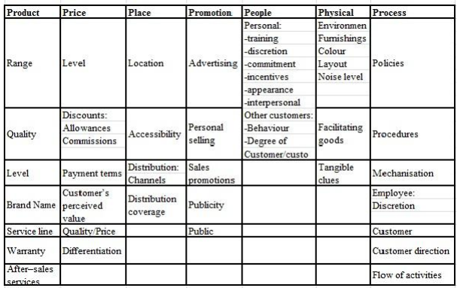(Source: Khadka, 2012)
Product implies the good and services gathering the ideas to the objective market. For instance, a wilderness safari comprises of a forest where a wide range of wildlife creatures are accessible and ensured, vehicle or an elephant for riding, security and shooter for individual security, a well prepared guide, and full guide of wilderness, very much arranged planning. It is vital for the organization to realize their ability to access the market as well as clients needs to comprehend that the product that they are selling is of customer interest or not. In the event that the time isn't appropriate for selling the product, it doesn't bode a good deal, which implies that the product should be suitable as per the environment and season time. It causes a great deal to find the right market, statistic, and most incredible season for support the products, and after that assistance arrange for the campaign. Precise services or product will give vacationer satisfaction and encouragement. Correspondence blend is the term used to incorporate publicizing, deals advancements, open and press relations, and work force selling, promoting and so on. The well mix of these strategies is the communication blend, which helps in selling. For our product, adventure activities travel, we should look for the market that caters to adventurers and young travelers, as per our data. They tend to involve in more adventure travel and that is what they look for when deciding on a destination.
Pricing is a component in advertising technique. There is no single strategy for setting up costs for all friendliness associated endeavors. Estimating end is affected by inner and outside variables. The inner components are product, circulation and advancement; whereas outside components are rivalry, financial strength of a nation, government guidelines, conduct of the voyagers, codes of practices and moral contemplations. Valuing is critical as it decides how purchasers see the product and unequivocally influences different components of the advertising blend. The marketing goals behind valuing are expanding market of the overall industry, expanding market share, advertise infiltration and money recuperation. (Advertising Methods, 2011). Therefore, when focusing on adventure activities pricing, one should know to that the target market comprises of young people with a limited budget to spend on. The evaluating strategy of the adventure tourism depends on destinations and on setting costs. In perspective on the rising patterns in competition and the changing economic situations, the adventure tourism industry can choose any three choices of either evaluating at the market, valuing over the market, and estimating beneath the market. In this manner, every one of the three options are at a non-cost rivalry. Hence, in comparison to other country's adventure activities, New Zealand can benefit from setting the cost according to the visitor's pattern.
Placement is where the product is conveyed to the client. Making the traveler product effectively accessible to purchaser, an advertiser needs to choose what circulation channels choice is controlled by the product. For adventure tourism, we need to display all the adventure activities that New Zealand's tourism has to offer. For instance, jet boating, skiing, kayaking and caving etc. The merchandise and ventures can reach the client by travel packages, retail travel operators, special adventure tour specialists (counting in travel firms, meeting and tradition organizers, hoteliers, administrators, corporate travel workplaces and so on) The width of the adventure travel industry should likewise be considered. New advancements must be given the inclinations while choosing the correct conveyance channels. According to the data, young people tend to do more adventure activities, so we may rely on social media networks to display our advertisement. The critical thing while at the same time choosing the appropriation channels are controlled by the different affecting components, for example, area of purpose of offers cost of dissemination, picture of the association, adequacy of the marketing endeavors, client's inspiration with respect to adventure sports, degree of market, expected participation from the channels use and the degree of help requested and desires.
Promoting or expanding the closeout of the product is basic to draw in voyagers' consideration, make them intrigued, create desire and get accomplishment. The fundamental role of the adventure tourism industry advancement is to get positive reaction from the purchaser and create demand for all the extreme adventure activities in New Zealand. In this way, promotion is critical as it makes mindfulness that the adventure tourism industry exists and it is effectively accessible, helpful and dependable. The promotion for the adventure tourism industry can be done through various channels such as social media and procedures like-print media notice, broad media notice, registries, transportation vehicles, expressway announcements, travel appears, travel movies and can be utilized in worldwide the adventure tourism markets. The medium ought to be chosen which is inside the financial plan, perfect with the picture of adventure tourism and administration being advanced, reasonable for our target market and geographic region of the business and so on.
People allude to the overall population or the clients, society, workers, the board and everyone that includes purchasing and selling. In each organization it is essential to influence all individuals to comprehend that the adventure sports and activities are a part of New Zealand tourism and through right channels they are easily accessible. Advertising that is executed, consolidates the guidance framework of the ongoing services of the administration by the shareholders involved in the discharge. Every enterprise wishes individuals that can offer look into guest's request and give them the data they are searching for. At last, it is quiet imperative to enquire, on the off chance, how you spread the general population to dispense data on the adventure tourism in New Zealand, its administration, or business on online journals, discussions, publications or blogs, broadsheet, article, occasions and so on by redistribution about it.
Physical proof shows to the information of utilizing an product or administration. At what time an administration goes out to the client, it is basic that an organization enables every one of the clients to perceive what they are purchasing or not. For instance, handouts, leaflets on adventure tourism in New Zealand and so forth fill this need. It is difficult for the travelers to be familiar by methods for how they can be assisted and directed in the case when they want to go for adventure sport activities while in New Zealand. In this manner, the person handing out leaflets or pamphlets can trade a couple of words such that the tourists will almost certainly feel no uncertainty while opting for adventure sport activities. We should also focus on doing reports and articles that will energize the tourists about the adventure sport activities in New Zealand and their services. Video and pictures additionally help the tourists feel great about adventure sports.
Process or Procedure is the method for doing errand with the best outcome. This is imperative in the field of the travel industry marketing in different activities like arranging, executing, and so forth. It identifies with the method and strategy of giving a service such as instructions or guidance while going for a particular adventure activity and is consequently critical to have deliberate data on whether such guidance are helpful for the tourists or not. In the event that they are given such instructions or help, in case, if the tourists are informed and treated well by the instructor, they are more likely to take the services further in the future. Procedure is one of the 'P's that is much of the time ignored. Tourists are not keen on the detail of how your business runs. What makes a difference to them is that the framework works. These sorts' issues or addressing make incredible impacts in the process for how it must be made. As a result, this 'P' could be extraordinary source of upper hand advantage whenever utilized astutely.

Distribution Channels
Digital channel will remain a principle channel and will be reached out towards portable. This remains the most focused on, pertinent and quantifiable channel to reach and draw in Active Considerers (people who are thinking about travelling in the near future). For the following future years, Tourism New Zealand will expand on the solid advanced stage that has been built up over the past years. A survey of Tourism New Zealand's digital movement has recognized a many open doors that will empower us to reinforce our methodology and execution carefully to expand inclination and change of Active Considerers (Australia Insights, 2018). One such open door is to adjust advanced movement more uniformly among inclination and change action through customized procedures. As of now, advanced action has been dominatingly change centered.
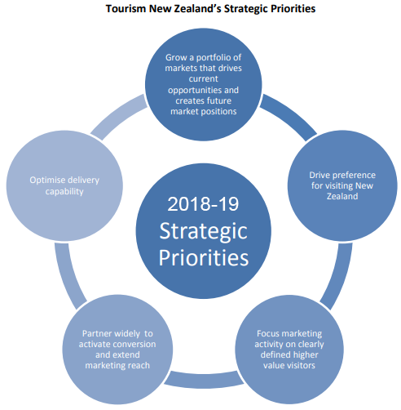
Source: Leveraging a strong foundation to accelerate growth, 2016
Some insights offer help for the job of Tourism New Zealand's PR group to concentrate on moving individuals to end up Active Considerers, just as fortifying those imagining about visiting New Zealand with endeavors essentially secured to disconnected properties by enlivening the experience. With ACs being to a great extent channel skeptic in their arranging, it's basic to guarantee that ACs can get to content fit to any phases of the way to-buy in the few key channels they like to utilize. Concentrate on empowering the New Zealand's airlines and its hotel administration to allude Tourism NZ's referrals back to newzealand.com to encourage customers in their way to buy, and drive an incentive for the NZ the travel industry.
There are sizeable sections of in the China, Germany, UK and USA AC markets that foresee expecting to accomplish more inside and out research for a New Zealand trip, contrasted with different goals. Despite goal however, most Active Considerers like to have adaptability incorporated with their sightseeing and adventure activity plans. Recommendations and schedules need to represent this; promote voyages that have a structure that additionally incorporate proposals for choices and choices for to see and to do, driving courses, spots to remain, number of days required, and so forth. This also guarantees it clear where different sights are to see and different adventure activities to do, and what their closeness is to different attractions.
Youth – who may dream of going with genuine relinquish – want in any event as much preparing as different ACs, offered weights to adjust time and spending plan. They investigate various instruments to enable them to decide on their budget, their time and cash over the scope of encounters they are hoping to attempt in New Zealand, either on newzealand.com or related to/by means of accomplices.
A huge minority of explorers will effectively proceed with research amid their trek, giving a chance to Tourism NZ to claim the full path to purchase. Empowering geo-area instruments by means of the application could invigorate another wellspring of client created content for Tourism NZ to catch and clergyman for future advertising; it would likewise give a vigorous view on guest conduct to supplement IVS (International Visitor Survey). This would likewise empower administrators to utilize area based focusing to promote specific messages/offers to visitors. This necessarily requires a talk with telecom and convenience suppliers to ensure that cost and system inclusion don't compel ACs need to be online or utilize versatile information amid their outing.
There are a number of specific online and offline sources for Tourism NZ to focus on when communicating with ACs (Planning behaviors & channel usage ACM FY15 bi-annual deep dive, 2015):
1. Traditional / offline media: Offline channels still have a significant role to play in motivating Active Considerers, and shouldn’t be minimized in planning. Each communication needs to have a strong affective component (to support the building of a meaningful emotional connection, which tends to direct future behaviour toward a brand) and be supported by some sort of call to engage / plan / action suggests a need to further understand the previous travel behaviour of New Zealand dreamers to assess the extent to which building desire for travel in general would be more effective than building desire specifically for New Zealand.
2. Word-of-mouth: This insight serves as a good reminder for the industry and related stakeholders (e.g. councils) to monitor and identify areas of under and over performance on visitor satisfaction with aspects such as: accommodation, transport, infrastructure and experiences Monitoring satisfaction might necessitate new ‘listening’ approaches, such as social media monitoring, to better understand the content of conversations people are having with their friends and family about New Zealand and in turn enable pain points and points of leverage to be identified New listening approaches would also give TNZ the opportunity to identify and curate positive word-of-mouth so that it can be re-packaged for marketing purposes.
3. Destination websites: Destination websites are consulted throughout the travel planning process – from when ACs are trying to decide which destination to visit, through to planning the specifics of their holiday once they’ve decided on a destination.
4. Travel agencies: Most ACs that prefer travel agents still like to have control / input, suggesting there is an element of ACs prescribing to travel agents their requirements and / or subsequently using other channels after consulting a travel agent. In a digitally driven world, travel agents still have a critical role to play in all markets, when it comes to transitioning ACs through the path to purchase.
5. Guide books: Planning for New Zealand is like planning for other countries and it’s common for people to use guide books to plan their travel, both before departure and during their journey. In the absence of foreign language websites and mobi-sites in the necessary language, a guidebook is a safe constant for travelers from China, Japan and Germany.
6. Social media: User-generated social media content is important for brands in the social space, as it is perceived to have greater credibility than brand generated content. Brand generated content (e.g. via Facebook, Web Chat, Twitter) does however have greater potential with the Youth segment, mainly at the initial planning and activity research stages. In most markets, Youth are more responsive to content about awards and accolades – ‘top ten’ or ‘best of’ lists in particular – which could provide fodder for content on / from brands’ social media pages.
7. Airline & hotel websites: ACs will consult specialist websites – airlines, hotel aggregators and hotel chains – when researching flights and accommodation.

Why is there a need for promotional tools?
Individuals in created nations are progressively advanced in their shopper conduct and less inclined to be influenced by 'hard-sell' publicizing systems It is more enthusiastically for organizations to set up extraordinary selling focuses or separate themselves in the market. Proliferation of news sources has let to extreme challenge for groups of onlookers and promoting spending. The crowd is divided and promoting must be spread over numerous outlets so as to achieve the objective market. Media promoting may not be the most practical method for achieving the objective market. Better to keep away from assumptions for any one limited time apparatus and select the most fitting one for the targets of every particular battle.
Customarily a business would connect with a publicizing/PR office who might configuration, oversee and actualize total scope of administrations from crusade arranging, inventive plan through to media purchasing and assessment look into, PR, deals advancement, and leaflet structure. Today organizations can purchase administrations from contending pro offices offering only one of the capacities, or handle a large number of these exercises in-house. This has cost focal points and puts the business in direct control of their marketing, however can weaken the message through various inconsequential and clumsy thoughts and executions.
Mix of advertising destinations and messages over the scope of limited time apparatuses and correspondences channels.
Integration of coordination of the promoting work inside the organization and its offices providing marketing administrations
This combination of one-to-numerous interchanges of the organization with its balanced contacts with the clients all through their association with the organization
This dimension of coordination requires contribution from the advertisers, the PR division (where there is one included) and with the offices in charge of offers and tasks as they are the forefront of the organization's cooperation with its clients.

Integrated Marketing Communication (IMC) Planning
The Integrated Marketing Communication (IMC) arrangements are structured explicitly for movement and the travel industry. This financially savvy yet novel device is on-going web based marketing bundle which incorporates components of SEO, SEM and SMM just as a significant online notoriety advance situation.
"INTEGRATED" is a key for understanding the arrangement's inclusion. The exceptionally exhaustive toolset is incorporated into the bundle. There are, for instance, conventional attention through official statements and advertorial content, sponsorship of included articles, web based life presentation, video advertising in the travel industry and so forth. Inside the IMC plan, the association warily joins and masterminds its various correspondence channels to pass on clear and dependable messages about the affiliation and item or organization.
The organizing plan incorporates getting a correspondence message to a customer; this message must be clear, relentless and persuading. The system of the IMC is basic for better managing the correspondence mix with target social occasions of individuals and keeping up the strong market position through brand partition (McClain, 2012).
The IMC arrangement pursues four fundamental focuses so as to advertise client's movement administrations:
> developing in general web notoriety of the movement business/office/goal;
> upgrading "look capacity" (advancing SEO) of the accomplice's site page over web indexes;
> creating mindfulness among potential partners/accomplices around the world;
> pulling in extra exceedingly focused on traffic (direct and from SE) to accomplice's site.

1. Doing a Situational Analysis
The chief period of the IMC organizing process is to lead a situational/coherent examination. This can incorporate a SWOT examination, and an external and inside common examination.

2. Choosing the target Markets
You need to pick who your target markets are, map them on a measurement and psychographic level. By then you need to pick what the points of interest are to the purchaser and why they would use the item.

3. Choosing the correspondence Objectives
The third step of the IMC organizing process is to pick what the correspondence goals are. These are goals that your association needs to pass on to the overall public and their expected intrigue gathering. A couple of instances of these are:
Create brand mindfulness by promoting: IMC advocates the utilization of a solitary full-administration organization or solid control by the customer organization so as to guarantee a brought together marketing interchanges methodology. Limited time materials incorporate publicizing such as PR, direct-marketing, sponsorship and deals advancement. Publicizing incorporates any paid-for correspondence in media went for the general population, customarily TV, radio, print (eg papers and magazines), film or video, publication locales, and now sites and other computerized and web-based social networking. Publicizing is paid-for 'space' utilizing cautiously controlled messages by an association. PR tries to get exposure for an organization and its products through news stories and highlights and the organization does not have direct power over the manner in which messages are utilized. Media publicizing includes the 'one-to-many' approach (one message appropriated to numerous individuals) though direct marketing includes coordinated correspondences with clients through the mail, web or phone. This maybe requires a more profound comprehension of which settings bolster online video to affect the gathering of people – for example for any single online video, in what condition is it liable to accomplish most extreme commitment? Relevant components include: site (for example Facebook, YouTube, TV on interest), time of day (for example drive, lunch, evening), gadget (for example versatile, tablet, workstation)
Pamphlets and other print materials speak to another unmistakable gathering of marketing interchanges for an arranged promoting effort, notwithstanding publicizing/PR and deals advancement and marketing. Travel and the travel industry depended vigorously on pieces of literature until the appearance and development of the web. The plan, dispersion and huge volume utilization of printed things has been a noteworthy distinctive element of movement and the travel industry advertising. Worries over wastage, cost funds, the need to adjust to an increasingly liquid estimating model, and buyer interest for persistent access to state-of-the-art data day in and day out has added to the move to online materials. Leaflets are currently accessible on the web, simple to peruse and explore, downloadable, printable, with shoppers being capable make notes inside a pamphlet, email it to a companion, 'similar to' it or spare it to a list of things to get for further perusing later.
Change client convictions by improving brand picture: Sales advancement includes a scope of strategic promoting strategies structured inside a key marketing system to increase the value of a product or administration n request to accomplish explicit deals or advertising goals Merchandising is any training which adds to the clearance of products to a retail purchaser. At a retail in-store level, promoting implies the variety of products accessible to be bought and the market of those products with the goal that vivifies premium and baits customers to make a purchase.
Increment deals: Determining the size, profile and needs of the intended interest group through market division and the advertising arranging process. Print volume depends on targets in the marketing plan. Marketing technique, marking and situating - print and site materials are arranged together with facilitated messages, pictures and situating.
Paper quality, selection of hues, thickness of duplicate and illustrations alongside style and thickness of photos coordinating pictures to chosen target groups of onlookers, guaranteeing pictures can be scaled for online use.
Determining leaflet/site/destinations: Elucidate what the handout or site is relied upon to accomplish in the competition and deciding the strategy for conveyance. Cost of dispersion frequently surpasses cost of print generation. Travel and tourism industry administrators need to pick appropriation choices that meet goals however limit cost. Innovative execution is the manner by which product ideas and pictures are.
Timing: Most literature are required to be accessible for appropriation at explicit occasions of the year (in booking seasons. which change contingent upon which part of the world the administrator is found). It takes a little while from the issuing of the underlying brief to the office or printer to definite generation of print. Sites can be substantially more promptly made and altered and furthermore, with negligible expense. For administrators in a liquid valuing market setting site adaptability is an appealing alternative as changing costs after materials are printed is amazingly expensive and tedious.

4. Financial plan
The sorts of spending that associations have can change. These can be a dimension of offers such as concentrated deficiency, dimension of advantage, a money related arrangement dependent upon goals and endeavors and how much the association can oversee.
Knowing the sorts of clients that make up your objective market will empower you to tailor your product to address their issues, desires and inclinations, and help ensure your advertising contacts the perfect individuals. We need to make adventure tourism in New Zealand enchanting to our clients and urge them to rave about it to their companions from their own experience. So you have to know a little about their identity and what they're searching for in a vacation understanding. This information will likewise enable you to arrange for when your business will be busiest, what number of clients you can hope to pull in, where you have to focus on your marketing and how to value your product.
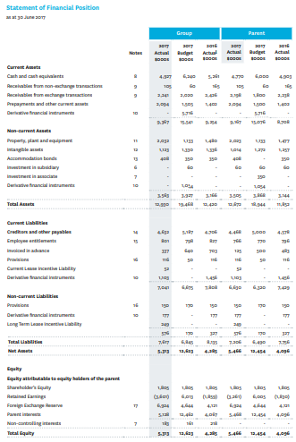
Source: NZ Tourism Report (2016-2017)
The best distribution channel for adventure tourism in New Zealand will depend on what we are selling and the outcome we are looking to achieve.
Cooperating and bundling products: To sell your products in the worldwide commercial center they should be unmistakable - therefore the most ideal approach to accomplish this is to be incorporated into distributer as well as retail leaflets. Be that as it may, the movement exchange will for the most part not include lower-valued products in their pamphlets on account of the lesser commission rates. Another approach to get around this issue is to consolidate your product with other complimentary products to make a bundle. This can be accomplished by working with other similarly invested the travel industry administrators to shape a promoting group that empowers you to offer wholesalers, specialists and inbound administrators a solitary product at a higher dollar esteem. Ensure you realize who you will work with. Complete an intensive check of the products alternate administrators are adding to the pack and ensure they live up to your desires of value, wellbeing and polished methodology.
Pick products that supplement one another: alternate products in the group should supplement each other here and there - so they all intrigue to your objective market - while offering an alternate sort of experience that will be of an incentive to your clients. For instance on the off chance that you offer a Maori social ordeal, you ought to consider packaging with different products that likewise have a social component.
Build up a deals and advertising procedure: Once you have built up your bundle it ought to be marketed independently to whatever is left of your business. Consider the conveyance channels you will utilize and build up the proper pamphlets and other advertising material. The administrators included should share the expense of marketing and advancement.
Dole out one gathering to deal with appointments and organization: It's best that one business holds duty regarding every one of the appointments and money related handling of the bundle. They should be in charge of sharing income from the bundle to alternate administrators required, at recently concurred dimensions.
Working with Inbound Operators: Inbound administrators are a one-stop-shop that deals with the correspondence, coordination and exchange process, making it straightforward for your product to wind up some portion of a globally sold the travel industry bundle. A standout amongst the most troublesome things about selling the travel industry products seaward is the understanding and arranging the global travel circulation process. Inbound visit offices or administrators (IBOs) are a technique for circumventing this system, a kind of one-stop-look for both all inclusive directors expecting to amass packages inside New Zealand, and for New Zealand visit managers who need to attract overall guests, yet don't have the resources for contributing a great deal of vitality building associations or voyaging. Inbound overseers can in like manner give you access to new markets through their arrangement of existing contacts. For worldwide wholesalers and retailers, an inbound visit chairman makes their dealings with New Zealand tourism business associations continuously streamlined. The IBO gives them minute by minute learning and a primary issue of contact, rather than arranging information from New Zealand the movement business chairmen, air ships, transport providers, etc. In perspective on the volume of traffic they oversee, IBOs can consistently organize better rates with motels and distinctive suppliers in light of a legitimate concern for abroad directors.
Building International Relationships: Working with worldwide travel merchants can be testing. Just as becoming more acquainted with another nation, new dialect and new circulation channels, you should be aware of the social conventions and business standards. On the off chance that you are not kidding about working together in another market it very well may be a smart thought to utilize somebody who knows about the way of life and language. This is especially imperative in nations like China and Japan, where social and business standards are very extraordinary and language can be an obstruction. In many markets, it's imperative to have standard eye to eye contact with the movement venders with whom you are working together. On the off chance that you are working through an inbound visit administrator, this isn't so critical, yet in the event that you intend to go direct to wholesalers or potentially operators, you should design normal deals visits to the market.
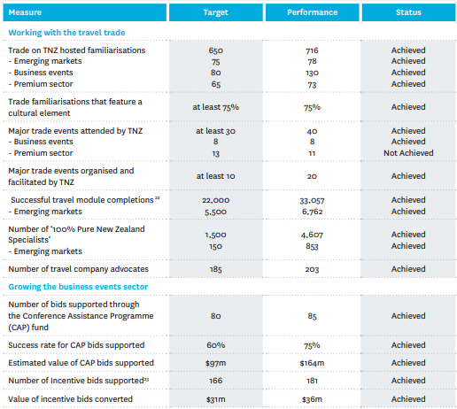
Source: NZ Tourism Report (2016-2017)

5. Marketing Mix Strategy
The showcasing mix is picked as per the correspondence targets and inside damage with the money related stipend picked.
A product is whatever can be offered to a market to fulfill a need or a need. In the matter of experience and the travel industry products, they are trekking, mountaineering, boating, kayaking, cycling, wilderness safari, horse riding, and visiting national park and natural life sources, outdoors in the wilderness, etc. In any case, the idea of product isn't constrained to physical articles yet anything equipped for fulfilling a need can be known as an product. In this way, the term product covers physical merchandise, administrations, and an assortment of other administration product that can fulfill.
The product ought to be appealing for the market or draw in the client and when the client is eager to take the product; the products ought to be strong and dependable. The improvement of the products is being investigations as the market potential; arranging and designing; financial; and lawful and business. At the point when the new or novel product is propelled there needs to think about numerous things to advance the products. For example, advertising, market division, target advertise, statistical surveying, investigation must be noted for the product. For example, wilderness boating is one of the experience exercises in New Zealand which is popular everywhere throughout the world and made a business opportunity for itself. Yet, this kind of experience product is in itself a one of a kind product.
There are additionally other experience products which are the same as existing ones yet in better administration giving. For instance, free guidance for the experience exercises like climbing, bungee hopping, and wilderness safari , giving the data of the related exercises, markdown in the products or free in certain products, giving the products at sensible cost and the state of the products are great and accessible for 24 hour, for example trekking. There are in every case more rivals in the market and the greater part of the plan of the product and the objective market is the equivalent. To advance those sorts of products is less demanding. Bringing the adventure tourism to New Zealand, for example, wilderness safari encounters, bungee hopping, climbing. To create and condescend the nature and experience product blend we need to consider the product way of life, product portfolio, pertinent holes, examination of vacationer fulfillment, and improvement of product separation.

6. Assessing the Program
The last development of the IMC orchestrating process is evaluating the program. This should be conceivable by certain electronic estimations, by inspecting on the web traffic with the usage of Google examination, by arrangements and online instruments that empower you to pursue responsibility with explicit things. This is the idea under which an organization cautiously incorporates and co-ordinates its diverse interchanges channels to convey an unmistakable, reliable and convincing message about the association and its items.
Research (Lim, 1981) taking a gander at the job of progressions in the selection of guests to visit New Zealand found that publicizing affected the certifiable decision in only few percent of cases while the majority percent of respondents felt that singular correspondence is the most fundamental variable in the decision to visit New Zealand. Singular selling (casual) is apparently the most overwhelming constrained time instrument as for the veritable purchase decision. 1995 research looked by which clients came to use a particular organization: 80% of all customers using organizations given by associations inside the tourism business in New Zealand did in that capacity as a result of recommendations from colleagues, families and others. The tourism business NZ has thought about the essentialness of individual selling for more than 10 years and has consolidated activities to address this key area of effect in its business parts. Singular selling exercises grasped by Tourism NZ include: The errand of abroad working environments in NZ's key making markets staffed by an arrangements and publicizing bunch who routinely progressed NZ o the trade (travel masters and overseers) in those business divisions.

Conclusion
Over portion of our universal occasion vacationers embrace a type of Adventure the travel industry while in New Zealand. Adventure tourism is attempted by youthful and old, male and female and is prominent in many markets. Adventure tourism is a standard New Zealand product that produces a noteworthy extent of New Zealand's travel industry related use.
The Tourism 2025 arranging structure is a device for improving the aggressiveness of the New Zealand the travel industry. The system has been grown explicitly for New Zealand the travel industry and gives a mutual arranging procedure and a typical language. The structure subjects have been distinguished both for their basic significance to an industry seeking to touch off development in esteem, yet in addition for their demonstrated toughness. Utilizing the Tourism 2025 structure will enable us to develop esteem exclusively and develop esteem together (Ngatahi, 2018).
Efficiency for benefit: Our quickest course to development will be to get more cash-flow from those speculations we have effectively made and those assets we as of now utilize. Improve our benefit and new venture will pursue. The Tourism 2025 structure prompts us to proceed with our look for new answers for regularity and new boosts for territorial spread and to separately discover approaches to improve our capacity.
Guest Experience: We perceive that tomorrow's visitors are probably not going to need business as usual: our changing guest blend carries with it the test of evolving desires. The Tourism 2025 structure prompts us to listen cautiously to our visitors, always sharpen our comprehension of guest needs and constantly improve our guest's involvement.
Network: Since New Zealand is an island, almost all the visitors travel either via air, thus availability is urgent. As we create regard together, the Tourism 2025 structure prompts us to invigorate the associations, affiliations and joint endeavors that proceed, develop and widen our visitor pipelines.
Knowledge: The Tourism 2025 system prompts us to gather and share significant information and transform it into important data with the goal that we are increasingly receptive to a quick evolving world.
Focus on: The tale of the previous ten years in the travel industry has been development in guest numbers however declining income in genuine terms. As our guest blend keeps on advancing, the Tourism 2025 structure prompts us to distinguish and seek after the open doors that will convey the best financial advantage.
The speed of progress in the worldwide tourism industry and accommodation ventures implies that travel industry businesses should be kept refreshed with contemporary patterns of marketing plans. The focal point of the worldwide economy is drawing nearer and the long haul standpoint is certain. Demand from these developing markets for movement to New Zealand will take off.

References
Annual Report. (2017). Tourism New Zealand. Available at: https://www.tourismnewzealand.com/media/3231/tourism-new-zealand-annual-report-2016-17.pdf
Australia Insights. Active Considerer (AC) Monitor Australia (H2 FY 18). (2018). Available at: https://www.tourismnewzealand.com/media/3643/australia-insights-h2-fy18.pdf
International visitor arrivals to New Zealand: July 2018. (2018). Stats NZ. Available at: https://www.stats.govt.nz/information-releases/international-visitor-arrivals-to-new-zealand-july-2018
Leveraging a strong foundation to accelerate growth. (2016). Tourism New Zealand Three Year Marketing Strategy FY2014 - FY2016. Tourism New Zealand. Available at: https://www.tourismnewzealand.com/media/1543/tourism-new-zealand-3-year-marketing-strategy-fy14-fy16.pdf
McClain, J. (2012). Integrated Marketing Communications Solution for Travel and Tourism Industry. Tourism Review. Available at: https://www.tourism-review.com/tourism-integrated-marketing-communication-promotes-effectively-news3459
Nepal Tourism Statistics 2017. (2018). Ministry of Culture, Tourism & Civil Aviation. Retrieved from: http://tourism.gov.np/files/statistics/2.pdf.
Ngatahi, W.U. (2018). Tourism 2025. Available at: http://www.tourism2025.org.nz/assets/Documents/TIA-T2025-Summ-Doc-WEB.pdf
Planning behaviours & channel usage ACM FY15 bi-annual deep dive. (2015). Available at: https://www.tourismnewzealand.com/media/2528/planning-behaviours-and-channel-usage-acm-fy15-bi-annual-deep-dive.pdf
Prasain, S. (2017). Tourism pumped Rs 177b into Nepal's economy. The Kathmandu post. Retrieved from: http://kathmandupost.ekantipur.com/news/2017-03-31/tourism-pumped-rs177b-into-nepals-economy.html.
Steinmetz, J. T. (2018). Nepal Tourism: looking good in the first Quarter 2018. Retrieved from: https://www.eturbonews.com/182762/nepal-tourism-looking-good-in-the-first-quarter-2018.
The IMC Planning Process (Integrated Marketing Communications). (n.d.). Cocoonfxmedia. Available at: https://www.cocoonfxmedia.co.uk/articles/the-intergrated-marketing-communications-planning-process-imc/#.XIZWASIzbIV
TRAVEL & TOURISM ECONOMIC IMPACT 2017 NEW ZEALAND. (2017). World Travel and Tourism Council. Available at: https://www.wttc.org/-/media/files/reports/economic-impact-research/countries-2017/newzealand2017.pdf

