HI5003
ECONOMICS FOR BUSINESS
A REPORT ON FUTURE STRATEGY OF METRICON HOMES
Student name
5/26/2019

Table of Contents
Executive Summary 3
Introduction 4
Introduction to the Metricon Homes 4
Industry Background 6
The Market Structure of Meticon Homes 8
Factors That Influence Demand for the Metricon Homes 9
Factors that Influence Supply of the Metricon Homes 10
Demand Elasticity 11
Impacts of an Event on the Metricon Homes 11
Conclusion 12
Reference List 13

Executive Summary
The marketing report is important to determine the marketing strategy of Metricon Homes for next five years. Metricon Homes is the biggest residential property developer in Australia. The purpose of making this report is to assess the company’s capability to sustain in the current market. The report starts with a general introduction and then followed by introduction to the organization. This section also provides a brief view of SWOT analysis of property development industry. A brief view on political, economical, social and technological factors is also provided in this report. The description of the company background includes some key statistics of the organization like its revenue, employment level, the industry’s contribution to national GDP, and industry growth rate. The market structure of Metricon Homes includes the type of market structure and the details of market leaders in this industry. The report gives a brief idea about two influential determinants of demand and two determinants of supply for the product of Metricon Homes. A discussion about the demand elasticity of the properties of the real estate industry is discussed. There are two factors that affect elasticity of demand the offered product of Metricon Homes. In this report, a past event of the company is addressed also. This event affected the market demand of the products of the company.

Introduction
An effective economic knowledge helps the business to sustain in the market. Here, the chosen industry is a property development industry in Australia. The name of the industry is Metricon Homes, Australia. Australian property development market is growing fast and the Australian economy is boosted up by the real estate industries (Moore & Higgins, 2016). The residential land prices in Sydney and Melbourne are falling but the economic condition and market demand will encourage property development industries in next five years. The property development industry will find lots of opportunities in next five years and will be at the centre of huge economic and social change. According to Gurran & Phibbs (2015), by 2024 property development industries will experience greater risks in this sector. These risks can be managed by the developers if they use effective strategic plan. Presently, this sector includes a long process which starts with planning and ends with construction and this process takes several years. But in the next five years this process will be changed. The report is about the economic conditions of the property development sector. An example of the past event that was faced by Metricon Homes will be discussed in this report.

Introduction to the Metricon Homes
Metricon Homes is a property development industry in Australia. According to Housing Industry Association (HIA), the company is the biggest residential developer in Australia since 2011. The company started their business in the year 1976 in Caulfield, Melbourne. It builds home, sell house and land packages, develop lands and construct commercial buildings. In 2017, it maintains its top position with 4365 new projects more than any other developer in Australia (Gurran & Ruming, 2016). The mission of the company is to create innovative property designs and build quality homes with all budgets. They aim to build homes where people would truly love to live. The vision of the company is to be the best property developer in Australia.
Metricon mainly builds single and double storey residential properties. They also rebuild old properties. They customize apartments according to customers’ choice and build display homes for investors. Metricon also offers homes and land packages where the customers can buy a block of land with a different interiors and exteriors. Later Metricon will build house according the customer’s preferred designs.
The price range starts around $200,000-1,800,000 depending on the location, designs and land size (Sohlberg, 2018). Currently their projects are in South Australia, Queensland, New South Wales and Victoria.
The company employs more than 1200 employees in specialized divisions (Anon., n.d.). Metricon introduced a new division named, TownLiving.
The management board of Metricon Homes includes gchief executive officer/founder/director, managing director, directors and chief financial directors (Anon., n.d.).
The following members are part of management board.
- Mario Biasin- Chief Executive Officer, Director and Founder
- Ross Palazzesi- Managing Director and Director
- Peter Langfelder- Director
- Jason Biasin- Director
- Ashley serebro- Chief Financial Officer and Director
SWOT Analysis
The SWOT analysis of Metricon Homes will help to make strategies for future. The SWOT analysis means strength, weakness, opportunity and threat assessment. Strengths and weaknesses are the internal environment of the organization whereas the opportunity and threat represent the external environment of the organization.
Strength | Weakness
- 4 decades in business  - Brand name  - Loyal customers | - High cost of finance  - Limited area served  - Vulnerable to local economic condition
Opportunity | Threat
- Expansion in all tier business  - Shortage of houses in urban areas  - Tax incentives for housing investment | - Rising land price  - Fluctuation in interest rate  - Economic downturn

Table: SWOT Analysis of Metricon Homes
Source: (Anon., n.d.)
PESTEL Analysis
PESTEL analysis helps to influence an organization directly. PESTEL analysis includes Political, Economical, Social, Technological, Environmental and Legal influencing factors of the organization. Every organization has these influencing factors which helps them to sustain in the competitive market. The following image is the graphic representation of PESTEL analysis of Metricon Homes.

Image: PESTEL Analysis of Metricon Homes
Source: (Sohlberg, 2018)

Industry Background
In this section, a detailed view of Metricon Homes will be presented. It will include some key statistics such as revenue, employment, the industry’s contribution to national GDP, and industry growth rate.
- Revenue of Metricon Homes: According to Housing Industry Association (HIA), Metricon Homes is the biggest property builder in Victoria, Australia. The revenue of the company is approximately $201.27 (Anon., n.d.).

Image: Revenue of Metricon Homes
Source: (Anon., n.d.)

- Employment: Property development industries are now considered as biggest employer in Australia. Metricon employs experienced employees who understand the vision of the company and achieve the company goals with passion and enthusiasm. The growth in employment level decreases the previous concern of Australia. The property development industry created 1.6 million jobs in Australia in last year.
- Metricon Homes’ contribution to national GDP: Property development industry is now larger than mining, home ownership, or financial industries. It contributes almost double amount to Australian gross domestic product in the last decade. It gave $462.2 billion contribution to GDP last year in Australia.
- Industry Growth rate: The property development industry is considered a profit earning industry. In Australia, the industry growth rate is currently in risk.

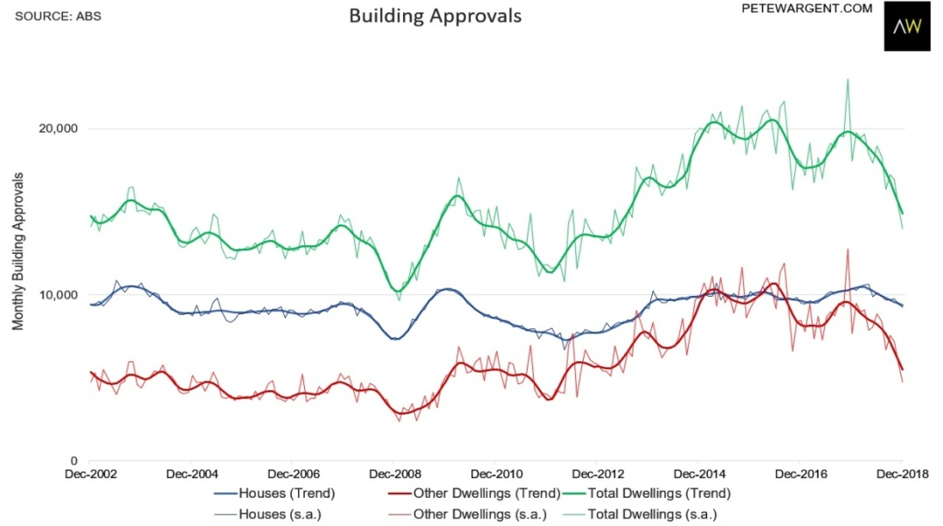

Image: Building approvals in Australia
Source: (Anon., n.d.)

The Market Structure of Meticon Homes
Type of Market Structure
The market structure includes the characteristics of the market that significantly affect the behavior and communication relationship of buyer-seller. Market structure includes perfect competition, oligopoly, monopoly and monopolistic competition (Brickley et al., 2015).
- Perfect competition- In perfect competition, a market has infinite numbers of sellers sell homogeneous products to infinite numbers of buyers. In this market structure, the sellers have the knowledge about market conditions. Here is no barrier in entry or exit. The demand curve of this structure is perfectly elastic. There is no Government intervention and the firm is a price taker.
- Oligopoly- In oligopoly market situation, there are few firms which produce either differential goods or closely differential goods. There is entry barrier for the firm. There are few competitors.
- Monopoly- Monopoly market structure has only one seller and there is no other substitute of the product. There is no competition. There is close entry. The firm in this structure is price maker. The demand curve is downward sloping.
- Monopolistic competition- In monopolistic competition, there are large numbers of sellers sell different types of products which are similar in nature but not homogeneous. It is a perfect combination of perfect competition and monopoly. There are no restrictions in entry and exit of firms. The demand curve is downward sloping. Price elasticity of demand is elastic.
After describing these four types of market structure, it can be said that property development business in Australia falls in monopolistic competition category. There are strong reasons behind this statement. The property development industries can easily start a business without any strong entry barrier and can exit from the business. Property development business industries build different types of buildings with different varieties. Australia has a large numbers of property developers which sell properties but they are not homogeneous. The demand curve is downward sloping means the consumers demand properties when the price falls.

The Market Leaders in the Industry and Their Statistics

Australian market has a large number of property developers who hold a good position in the market and they are market leaders in the industry. The following companies are market leaders.
- Dyldam developments- Dyldam developments was ranked the second biggest property developer by Housing Industry Association (HIA) in 2017. Now it is the biggest apartment developer in Australia (Sohlberg, 2018). They develop medium and high-rise apartment buildings within and around Sydney.They also develop commercial, retail and many mixed projects.
- ABN Group- ABN Group was the third biggest property developer in Australia in 2017 by HIA. It offers house and land packages. The group assigns many own subsidiaries.
- Brookfield Multiplex- Brookfield Multiplex is an international construction contractor and property developer. It builds high rise buildings, and offers various types of projects like commercial buildings, educational projects, and sports project.

- Meriton Apartments- Meriton Apartments is a big property developer in Australia. It builds high rise service apartments. It is the 5th biggest property developer by HIA in 2017.

- MJH Group- MJH is also a big property developer in Australia. It owns many subsidiaries. It builds commercial, residential, townhouse, retirement villages and government buildings.

Factors That Influence Demand for the Metricon Homes
There are some determinants which influence the demand elasticity for a product. Here the chosen industry is property development industry and under this category, the chosen company is Metricon Homes. So the product in this case is property. The demand elasticity is the sensitivity of the demand for a product due to a change in another factor (Chen, 2016).
In this case, the two determinants of demand for Metricon Homes are price and income level.
- Price
Price is one of the most influencing demand factors for Metricon Homes. For an example, the change in a price level for a property can cause a significant change in the quantity demand. If the property developer has a shortage of buildings, it may increase prices to decrease the quantity demanded. As a result, there will be increment in inventory and increment in Metricon Homes’ total revenue.
- Income Level
Income level of consumers highly influences the demand elasticity for a product. In this case, when income level of buyers rises, the demand for the product increases. When income level falls, the quantity demand decreases. But when income level is double, the buyers may not buy double quantity of the products. The changes in the income level of the majority population of a country causes luxury items to be more elastic. Metricon Homes have such customers who act upon the changes in their income level. They tend to purchase houses which match their income level. The demand of their projects increases when the income level of the Australian population increases.

Factors that Influence Supply of the Metricon Homes
There are some determinants which influence the supply elasticity of a product. Here the chosen industry is property development industry and under this category, the chosen company is Metricon Homes. So the product in this case is property. The supply elasticity measures the change percentage in supply due to a change in another factor. It means how the quantity of supplied product changes in response to price or other factor.
In this case, the two determinants of supply for Metricon Homes are price and cost of production.
- Price

Price is also an influencing factor for supply elasticity of a product (Zhao & Burge, 2017). There is a strong relationship between price and supply of a product. If the price decreases, the supply of the product increases and vice versa. Zhao & Burge (2017) stated that future price can also influence supply of the product. For an example, the change in a price level of raw materials highly influences supply of Metricon Homes’ properties. If the raw materials of building decrease, then the supply level will be high. Another example is that if the price of the Metricon properties falls then the supply of the property will increase.

- Cost of production
The supply of Metricon Homes will decrease with increase in the cost of production and vice versa. The supply of Metricon Homes The supply of the properties and cost of production are inversely related to each other. Metricon Homes supplies less quantity when the cost of production exceeds the market price of their properties.

Demand Elasticity
Demand elasticity means how a product is demand sensitive when there is a change in other factors like price and income level. The calculation of demand elasticity is the percentage change in quantity demanded divided by a percentage change in other factors. If there is an increment in demand elasticity for a factor it means that consumers response to the changes in the variable. Metricon Homes’s products are elastic as the demand changes when there is a change in other factor such as price or income level of the consumer.
The two factors that affect the elasticity of demand for Metricon Homes are avalibility of substitutes and postponement of consumption.
- Availability of substitutes
When there is a rise in price, buyers tend to purchase from substitutes. In this case, when Metricon Homes increases their property purchase price, many consumers tend to purchase products from substitute property developers like ABN Group and MJH Group. It means there is a price elasticity of demand.
- Postponement of consumption
Metricon Homes sometimes have such buyers who postpone purchasing property due to hike in prices. This has also highly elastic demand.

Impacts of an Event on the Metricon Homes
Brief Description of the Event
Australian property development industries are suffering huge problems since last five years. The home values across Australia have been decreasing since 2017. According to AFR, the house prices fall 9.3% in Sydney and 11.4% in Melbourne (Baur & Heaney, 2017). There were mainly two reasons for this event. The first reason is that the four banks in Australia- Commonwealth Bank of Australia, Westpac Banking Corp, Australia and New Zealand Banking Group and National Australia Bank Ltd enacted wrong lending restrictions in light of the royal commission. They also gave new impetus to APRA and ASIC. The second reason is Labor’s negative gearing policy was misinterpreted.
Demand of Metricon Homes’ Property Affected For This Event
This event also affected the demand of the Metricon Homes’ properties. The Labor’s proposed policy was made to make housing affordable but it ended up with overall housing market crash in Australia. The demand of the property decreases as the buyers had to pay a lot (Anon., n.d.). The interest amount for paying the loan and other costs associated with the loan for the purchasing property is higher than the income level of the buyer. They understood that they were making cash flow loss. Therefore the demand of the property is highly affected for this event.
Effect on the Market Price for This Event
The market price of properties is declining at a fastest rate due to this event. The property development industries experience gradual declining in property prices. The situation witnesses that first-home buyers have greater choice for purchase. There is an opportunity for the upsize purchasers.

Conclusion
The report presented how economics is related with business. The chosen industry for the paper was Metricon Homes. The market structure of the Metricon Homes is monopolistic competition. The price and the income level influence demand elasticity for the product. The cost of production and price are influential factors for supply of the product. Therefore it can be concluded that it is important to assess the economic conditions of every business before making any strategic plan for future.

Reference List
Anon., n.d. Australian Bureau of Statistics. [Online] Available at: https://www.abs.gov.au/.
Anon., n.d. Metricon. [Online] Available at: https://www.metricon.com.au/.
Baur, D.G. & Heaney, R., 2017. Bubbles in the Australian housing market. Pacific-Basin Finance Journal, 44, pp.113-26.
Brickley, J., Smith, C. & Zimmerman, J., 2015. Managerial economics and organizational architecture. McGraw-Hill Education.
Chen, Y., 2016. Comparative Static Analysis of Equilibrium of Supply and Demand in China's Property Markets. International Conference on Management Science and Innovative Education.
Gurran, N. & Phibbs, P., 2015. Are governments really interested in fixing the housing problem? Policy capture and busy work in Australia. Housing studies, 30(5), pp.711-29.
Gurran, N. & Ruming, K., 2016. Less planning, more development? Housing and urban reform discourses in Australia. Journal of Economic Policy Reform, 19(3), pp.262-80.
Moore, T. & Higgins, D., 2016. Influencing urban development through government demonstration projects. Cities, 56, pp.9-15.
Sohlberg, M., 2018. Top 13 Property Developers in Australia: The Definitive Guide. [Online] Available at: https://www.asiapropertyhq.com/property-developers-australia/.
Zhao, L. & Burge, G., 2017. Housing wealth, property taxes, and labor supply among the elderly. Journal of Labor Economics, 35(1), pp.227-63.

