CORONARY ARTERY DISEASE

Table of Contents
Introduction 3
Homeostasis and normal physiology 3
Pathophysiology and mechanism 3
Pharmacodynamics 3
Practice relevance 4
Conclusion 5
Reference list 6

Introduction
This assignment is focused on demonstrating homeostasis, pharmacokinetics, side effects, treatment and practical relevance of coronary artery disease through the drug Metoprolol.

Homeostasis and normal physiology
Homeostatic imbalance occurs at time of coronary artery disease as patients’ arteries become narrow and thus limits blood flow. According to Bønaa et al. (2016), coronary artery ailment can be signaled by acute angina to cardiac arrest. In a majority of Australian population, this condition occurs due to genetic factors or lifestyle factors. The drug Metoprolol widely distributes throughout the body. It metabolises into inactive metabolites mainly in the liver. The excretion of this drug is generally through urine largely as metabolites (Stone et al. 2016). It is generally excreted within 72 hours of administration.

Pathophysiology and mechanism
Coronary artery diseases in human body can develop in case the blood vessels supplying the blood, nutrients and oxygen are hardened by irregularities in fat and calcium deposition (Valgimigli et al. 2017). The mechanism of Metaprolol is that it is a beta-1 selective compound that is moderately lipophilic in nature. It has intrinsic sympathomimetic and membrane stabilising properties.The drug Metoprolol is usually absorbed in the duodenum in the alimentary canal.

Pharmacodynamics
Prime medication involves Beta blockers (Metoprolol). Side effects that may occur are weight loss, wound infection, and cardiac pain (Stone et al. 2016). The half life of this drug is about 3 to 4 hours. The availability of this drug in the body remains up to 3 to 6 hours. Indication for application of this drug can be addressed for coronary artery disease as it has elongated duration of action, higher bioavailability, intrinsic sympathomimetic activity and beta-1 selectivity. Metoprolol is a medication particularly of β1 receptor blocker type that reduces the uptake of Sodium ions and release of Potassium ions (Bønaa et al. 2016).
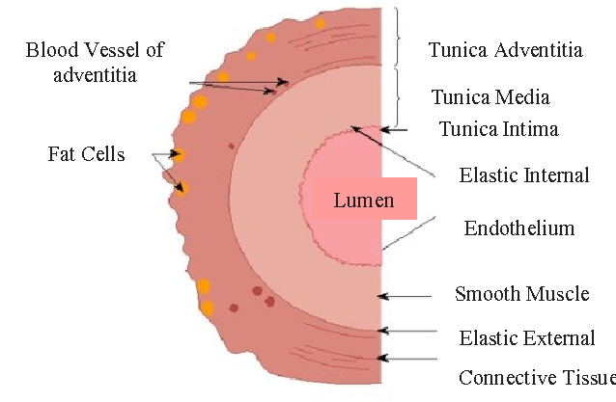
Figure 1: Occurrence of Coronary Artery Disease in the UK
(Source: Learner)
Contraindications that can be mentioned here are low blood sugar, sick sinus syndrome, myasthenia gravis, diabetes, complete heart block, asthma attack and other many symptoms. As per Nikpay et al. (2015), precaution for Metoprolol is that it should be avoided before major surgery operations or application of cardiac contrast medium.

Practice relevance
Route of administration for Metaprolol is through intravenous pathway, at the rate of 50 mg per 6 hour. Douglas et al. (2015) comment nurses must help patient to manage fluctuating blood pressure. Metoprolol functions by reducing the heart rate, lowers blood pressure and improves blood flow.

Conclusion
Coronary artery disease has become a very common disease nowadays due to increased lifestyle up-gradation. Maintaining a healthy and balanced diet along with the pharmacological treatment is essential.

Reference list
Journals
Bønaa, K. H., Mannsverk, J., Wiseth, R., Aaberge, L., Myreng, Y., Nygård, O., ... & Bendz, B. (2016). Drug-eluting or bare-metal stents for coronary artery disease. New England Journal of Medicine, 375(13), 1242-1252. DOI: 10.1056/NEJMoa1607991
Douglas, P. S., Hoffmann, U., Patel, M. R., Mark, D. B., Al-Khalidi, H. R., Cavanaugh, B., ... & Khan, M. A. (2015). Outcomes of anatomical versus functional testing for coronary artery disease. New England Journal of Medicine, 372(14), 1291-1300. DOI: 10.1056/NEJMoa1415516
Nikpay, M., Goel, A., Won, H. H., Hall, L. M., Willenborg, C., Kanoni, S., ... & Webb, T. R. (2015). A comprehensive 1000 Genomes–based genome-wide association meta-analysis of coronary artery disease. Nature genetics, 47(10), 1121. DOI: 10.1038/ng.3396
Stone, G. W., Sabik, J. F., Serruys, P. W., Simonton, C. A., Généreux, P., Puskas, J., ... & Taggart, D. P. (2016). Everolimus-eluting stents or bypass surgery for left main coronary artery disease. New England Journal of Medicine, 375(23), 2223-2235. DOI: 10.1056/NEJMoa1610227
Valgimigli, M., Bueno, H., Byrne, R. A., Collet, J. P., Costa, F., Jeppsson, A., ... & Montalescot, G. (2017). 2017 ESC focused update on dual antiplatelet therapy in coronary artery disease developed in collaboration with EACTS. European journal of cardio-thoracic surgery, 53(1), 34-78. DOI: 10.1093/ejcts/ezx334

