Project Plan for Conveyor System

Student Name

University

Conveyor system with loading, unloading and material movement:
The conveyor system consist mainly three elements such as “conveyor belt support”, “pulley/roller” and “drive unit”. As per the customer requirement, the material handling unit design for transfer product from company to new factory.
For that, the “belt driven roller conveyor system” needs to design. The conveyor system consist mainly three element such as automatic belt conveyor that receive material from company’s warehouse, the roller conveyor which transfer product from company to factory and constructed over the main roadways Chavan, P. (2017).
The angle between ground level and loading belt conveyor is$θ=45°$. The clearance between the buildings adjacent to the roadways is 6m. The clearance or vertical distance from road surface and roller conveyor is around 6 m so that it will not interrupt by transportation Brantuo, S. (2009).
$$length of loadin and unloading belt conveyor=\frac{6}{sin45}=8.48 ≈8.5 m$$
$$Speed of conveyor belt = πDN$$
$$D=Diameter of pulley=30 mm$$
$$N=1440 rpm$$
$$Speed of conveyor belt = \frac{π x0.03 x 1440 }{60}=2.26\frac{m}{s} ≈2.5\frac{m}{s}$$

The products may facility per hours:
Speed of belt conveyor = 2.5 m/s
Total length of span to receive and deliver product from company A to Company B = 18 m
The size of product 1$m^{3}$ i.e. minimum 1m occupied over conveyor when one product transfer from company A and company B. As considering conveyor speed, the 500 products/hours can deliver from company A to B Wang, Y. (2013).

Space Require for conveyor system:
The company A is require for conveyor installation near to dispatch area. By considering product size with tolerance, the space require for dispatch area is around 7 x 3 m. the detail design or sketch of spaced occupied for loading belt conveyor is provide in Appendix –B. the space require for company –B for unloading product is similar to company-A for easy installation and maintenance Zhang, C. (2015).

Overhead clearance for roller conveyor across roadways:
As provided in figure, the roller conveyor passes across the roadways. The designer ensures that the accident, collision may not occur through roller conveyor when heavy vehicle such as truck passes from that road. Therefore, the roller conveyor needs certain height or clearance from road surface. According to survey Wan, J. (2013), the maximum truck or heavy vehicle height is around 4.5 to 5m. Therefore, the 6 m clearance between roller conveyor and roadway is suitable to avoid collision and transportation interrupt.
Support structure:
- Lubrication oil: as per requirement of conveyor equipment.
- Grease: as per requirement
- Steel ladder (6 x 1 m length): for roller conveyor maintenance.
- Steel Hand Skiver: for grip while roller conveyor maintenance.
- Pneumatic air compressor: for dust, debris cleaning.
- Color paint: for prevention from corrosion.
- Steel roof over roller conveyor: protection from rain Zhu, Y. (2014).

Costing of conveyor system design:
Equipment uses for conveyor system:
Sr. No. | Particular | Cost
1. | Construction cost | 60000
2. | Material cost | 26470
3. | Supportive structure cost | 12145
4. | Foundation cost | 6500
5. | Lubrication cost | 2500
6. | Maintenance cost | 15625
Total cost |  | 123240
Material Require for conveyor system:
Sr. No. | Particular | Quantity | Material | Cost ($) | Total cost ($) | Supplier
 | Steel square channel for conveyor structure. (50 x 50 x 1.6) | 40 meter | Steel | 79 | 3160 | Scott metals
 | Conveyor belt | 25 meters | Stainless steel | 50 per meter | 1250 | HMB Engineering
 | Roller (40x 40 x2) | 8-10 No. | Steel | $74 per meter | 740 | Scott metals
 | Pulley | 6 | Steel | 45 per piece | 270 | Revolution industries
 | Steel C-channel for roller support (100 x 100 x 6) | 12 meter | Steel | 80 per meter | 960 | Scott metals
 | Roof protection (1.5mm thickness) Guan, W. (2017) | 6 meter | Aluminum | $15 per Kg | 90 | Atlas steel
 | Cement , Concrete for foundation | 1 tones | Cement and concrete | 20 per kg | 20000 | Holcim
Total |  |  |  |  | 26470

References
Chavan, P. (2017). Review Paper on Low Cost Conveyor Design Reduction of Weight of Conveyor System. International Journal for Research in Applied Science and Engineering Technology, V(III), pp.1099-1104.
Cheng, X. and Wan, J. (2013). Retractable Conveyor Control System Design Based on PLC. Advanced Materials Research, 655-657, pp.1332-1336.
Design & Development of Automatic Conveyor Controlling System for Sorting of Component on Color basis. (2016). International Journal of Science and Research (IJSR), 5(2), pp.1862-1866.
Guan, W. (2017). Speed Chain Conveyor Line Control System Design. DEStech Transactions on Materials Science and Engineering, (icmsme).
Temeng, V. and Brantuo, S. (2009). Design and Selection of a Belt Conveyor System for Increased Capacity. Ghana Mining Journal, 9(1).
Wang, Y. (2013). Study on Mechanical Automation with X-Ray Power Conveyor Belt Nondestructive Detection System Design. Advanced Materials Research, 738, pp.256-259.
Zhang, C. (2015). Design of Belt Conveyor Control System Based on Motion Controller. Applied Mechanics and Materials, 733, pp.710-713.
Zhao, P. and Zhu, Y. (2014). Design and Application Analysis of Coal Mine Belt Conveyor Automation System. Advanced Materials Research, 1044-1045, pp.759-762.
https://www.scottmetals.com.au/rhsgalv
http://www.hmbengineering.com/
https://www.revolutionindustries.in/
http://www.atlassteels.com.au/
https://www.holcim.com.au/

Appendix:
Conveyor System Assembly:
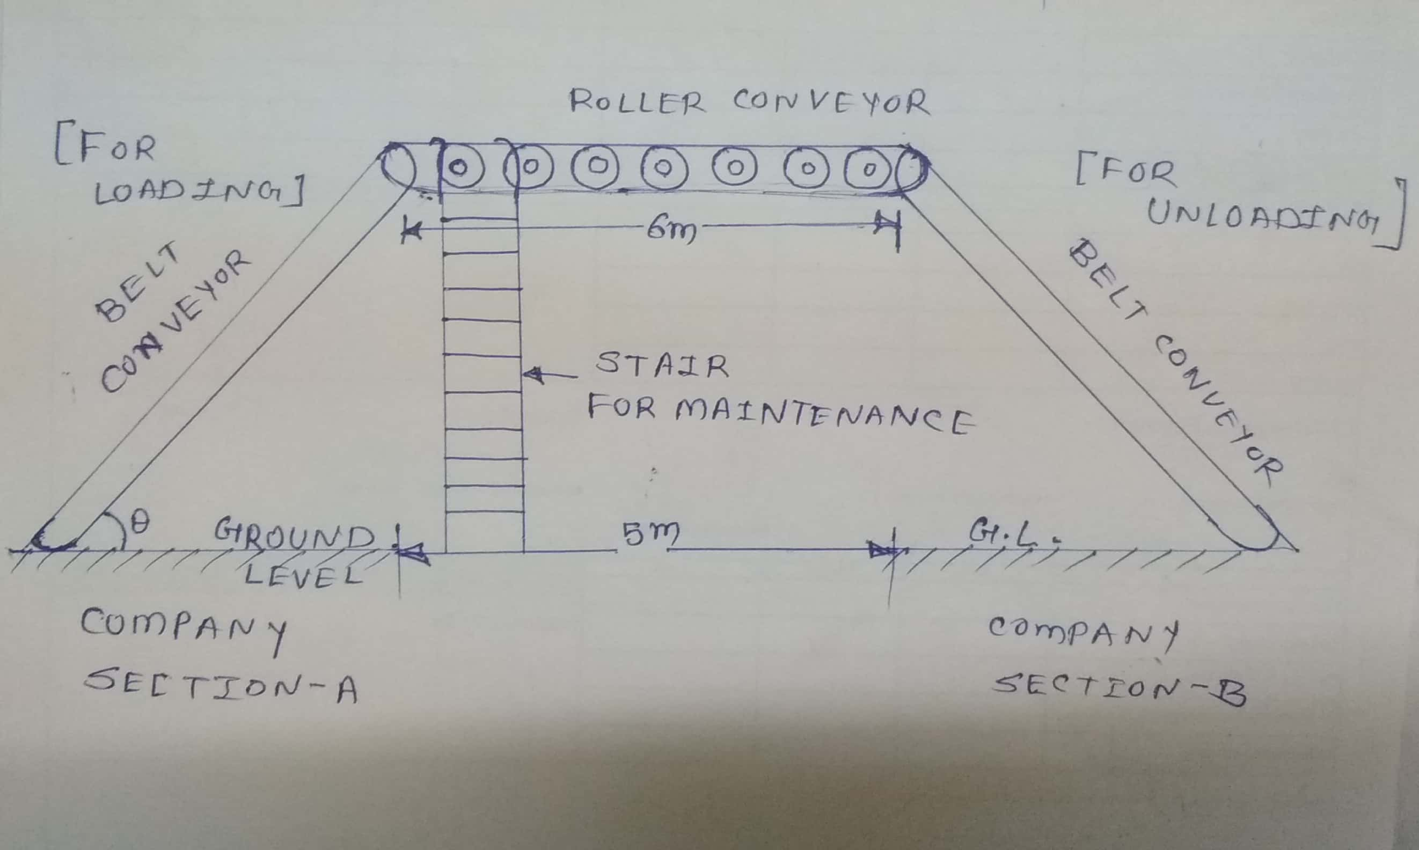
Space require for installation of incline conveyor (Top View):
